Creating your Development Needs Analysis (DNA)

The four activities in this form have been designed to guide you in tailoring your Development Needs Analysis (DNA). These can be completed in any order, depending on where you are in your studies. There is no right or wrong answer to these activities. Take time to reflect on each activity and **write your responses on this form**.

For additional guidance on the activities, please refer to the DNA handbook: [**edin.ac/3EJB4dL**](http://edin.ac/3EJB4dL)

If you are a supervisor, please consult the Supervisor handbook: **URL TBC**

It is strongly recommended to complete your DNA with your supervisor but it can also be useful for individual reflection and discussion with peers.

**Activity 1:** General reflection

# Taking stock – where are you now?

For this first part of Activity 1, take stock of where you are now and what you have already achieved. It’s important to start your reflection by assessing what skills, experience and knowledge you already master.

## Research project

## Career

Reflect on these achievements in three distinct (and often overlapping) areas:

* + your **research project**

## Personal development

* + - your **career**
    - your **personal development**

# Vision – where do you want to go?

1. Start from the centre of the diagram (inner circle) and write down your goals according to the three areas (research project, career and personal development)

# How Development

**I**

**d**

**d**

**What**

**F**

**i**

**e**

**l**

**l**

**n**

**i**

**t**

**n**

**i**

**f**

**g**

**y**

**i**

**n**

**g**

**g**

**a**

**n**

**c**

**v**

**e**

**e**

**s**

**n**

**g**

**e**

**o**

**e**

**a**

**d**

**l**

**e**

**s**

1. Building on each of your previous responses reflect on what skills and experiences you need to get there (middle circle)

**m**

**p**

**a**

**n**

**s**

**er**

**i**

**e**

**Research project**

**Personal**

**e**

**d**

**t**

**o**

**a**

**c**

**h**

**i**

**e**

**Career**

**development**

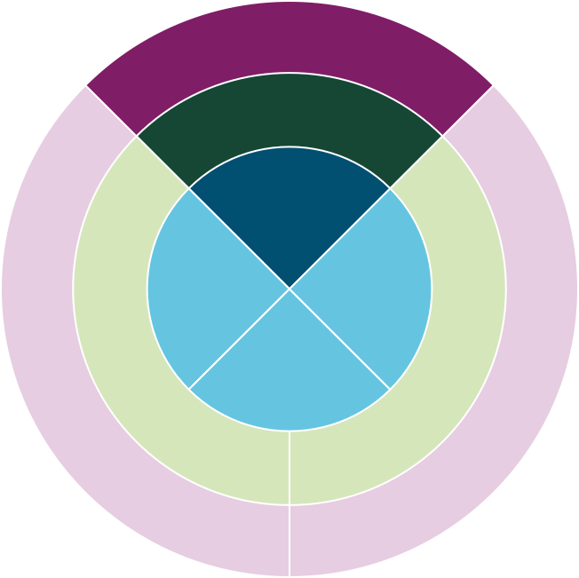

**a**

**a**

**g**

**e**

**n**

**a**

**d**

**b**

**l**

**e**

**e**

**s**

**x**

**t**

**p**

**e**

**p**

**e**

**s**

**r**

**i**

**e**

**n**

**c**

**e**

**s**

**S**

**k**

**w**

**i**

**l**

**t**

**l**

**o**

**s**

**g**

**n**

**a**

**i**

**n**

**e**

**s**

**e**

**k**

**d**

**i**

**l**

**l**

**s**

**a**

**n**

**d**

**e**

**x**

**p**

1. How can you acquire those skills and/or experiences? (outer circle).

**H**

**o**

Your responses here should be composed of small, targeted and manageable tasks.

**Activity 2:** Career path

* 1. **Necessary** – What skills and experiences do you **need**?

**Academic career**

**Exploring career options**

**Non-academic career**

(regardless of your interest in them)

**Ideas**

**Skills and experiences required**

* 1. **Desirable** – What skills and experiences do you **want**?

(i.e. that can contribute to your personal/professional goals)

**Necessary Desirable**

**Activity 3:** Timeline of priorities

Take items from your to-do lists and place them in your timeline of priorities, based on the following questions:

1. How much time do you have left to complete your research degree?
2. Which of the skills and experiences in your to-do list are your most immediate priorities?
3. What development activities could help you acquire these skills and experiences and when?

## Beginning stages

## Mid stages

## End/final stages

## Post research degree

**Activity 4:** Building your DNA ecosystem

Your DNA ecosystem is made up of the tailored network that you build to support you on your professional and career journey.

To create your own ecosystem, reflect on the following questions:

1. What exactly do you want help with?
2. Who are the right people to support and mentor you with this?
3. Why them specifically?

**Professional networks**

**Social networks**

**Me**

**Research groups and networks**

**Other communities**

We gratefully acknowledge that funding for the development of this resource was provided by the University of Edinburgh Development Fund as a project under the Principal’s Teaching Award Scheme (PTAS).



This resource is shared under a Creative Commons Attribution 4.0 (CC BY) licence. Please acknowledge the University of Edinburgh if you reuse.

Version 1 – July 2025

If you require this document in an alternative format, such as large print or a coloured background, please contact: [fiona.philippi@ed.ac.uk](mailto:fiona.philippi@ed.ac.uk)