Efficient and Effective Academic Reading

Online Resource



Contents

- Introduction: Become a Better Reader

- Section 1: Knowing Yourself - Recognising your toolkit and refining existing behaviours

- Section 2 | Strategic Focus - Making robust decisions about what to specifically to read and how to read it

- Section 3 | Habitual Consistency - Building a set of effective and efficient habits

- Section 4 | Criticism and Comprehension - Building a rigorous intellectual toolkit

- Section 5 | Rapid Reading - Techniques to increase your reading and intake speed

References

Throughout this document, there are a number of questions where you will need to record your thoughts and practices. To save space, we have not provided boxes for you to fill in, but you will find it invaluable to record your answers and insights in whatever way you prefer.

This work is licensed under a CC BY-NC-ND licence
To view a copy of this license, visit: | https://creativecommons.org/licenses/by-nc-nd/4.0/

Introduction | Become a Better Reader
Reading is perhaps the most important academic skill that we possess. But ask yourself when was the last time you actually learned anything that made you a better reader? Certainly we get cleverer and gain more academic knowledge which aids our comprehension of a text, but we don’t necessarily read any given text more effectively or efficiently.
This guide will examine a number of core facets of reading, pose some questions of you about your reading habits and suggest some simple models, tips and techniques to hone your reading speed and comprehension.

This guide will be structured around these five broad areas:





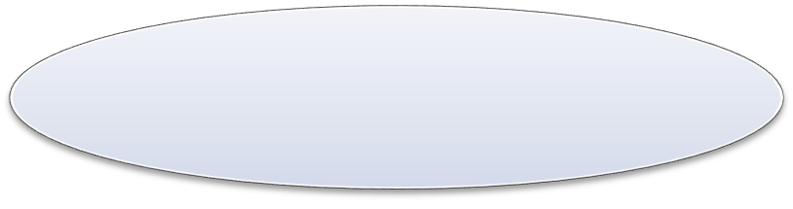
Criticism and Comprehension
Building a rigorous intellectual reading toolkit
Rapid Reading
Simple techniques to increase your reading and intake speed
Know Yourself
Recognising your toolkit, refining existing behaviours and undertaking conscious practice

Strategic Focus Habitual Consistency
Making robust decisions about what to Building a set of effective and efficient read and how to read it reading habits.

Warning!
By the time we reach adulthood most of our reading habits – including the less helpful ones - are firmly installed and require some conscious effort to rewire. Many of the strategies in this document require initial effort and sustained conscious practice.

Section 1 | Knowing Yourself

Recognising your toolkit and refining existing behaviours
Before you start learning new techniques, take a few minutes to pause, take stock and reflect on the tools that are in your reading and processing toolkit. You may find that these following questions aid your thinking:

Overall
What reading habits do you have that particularly help your effectiveness? What habits do you have that limit your effectiveness?

Building the Right Environment
What physical conditions do you need to concentrate most effectively? What is your best time(s) of day to focus? Do you protect this time?
Do you effectively remove distractions?
For how long can you effectively focus without taking a break? (NB – sitting at your desk, with a paper open and checking social media is not focusing…)

Information Seeking and Capture
Do you have a cogent literature searching strategy?
Are your searching tools up to date and suitably refined?
How do you decide ultimately what to read? (and NOT to read?)
Are your personal cataloguing systems and reading databases up to date and comprehensive?

Note Taking and Processing
Do you have a consistent note-taking method? Is it effective?
Do you find yourself re-reading papers, because your own notes were poor?
At note-taking stage, can you separate out your ‘factual’ notes (i.e. what the author says) from your ‘critical’ ones (i.e. what you think of their work)?
Does your strategy change according to the relative (to your ‘thesis’) value of the article?

ENQUIRY - In the light of your answers to these questions, what do you need to change and refine?

Tip – To be an effective reader, always remember ‘TYPE O’
Turn Your Phone and Email Off!

Now, go to your academic reading pile / file and choose an article to read.

Before You Start to Read
- Why did you choose to read this article? What are you reading it FOR?
- What type of information do you seek?
- What questions are you looking for the answers to?
Clarify these questions before you start to read an article since in all tasks you become more efficient if you know your purpose. You won’t always know what information you are seeking (especially at the start of a project), and simply reading around the topic is perfectly valid, but a clear focus undoubtedly helps.

As You Start to Read
- How typically do you approach the reading process? (i.e. graphics first, or a quick skim through, or start with the abstract and conclusions etc).
If you have a refined process for reading a paper (linked to your purpose) then this can improve your efficiency. (For instance, many experienced scientists start with the Abstract and then jump straight to the graphics, since that is where much of the
intellectual ‘value’ is contained.)

And when you’ve finished the article…
- How useful is this material going to be to you?
- Ask yourself ‘So what?’ – (i.e. does this paper add value?)
- How pivotal will this be to your ‘thesis’?¹ Is it key (and so you will probably cite it on multiple occasions) or is it peripheral?
Ensuring you ask the ‘so what?’ question helps sharpen your more refined critical skills. What’s more it prevents you from accidentally disappearing down intellectual side-tracks. These tracks may be productive, or may not – but at least you’ll recognise them as side-tracks.

Your Notes
- Have you taken sufficient notes on this paper?
- Will you need to re-read it? Why? Because it’s valuable (good) or because you won’t be able to decipher your margin scrawls in two years time (bad).
The quantity and quality of the notes that you take should be correlated to the value that the paper adds to your ‘thesis’. Also if your notes are simply to paraphrase what an author is saying (as opposed to critically engaging with the material) then typing and carefully saving your notes in full academic prose (not just bullet-points) will save you re-doing this job months later when you’ve forgotten it all.

¹ In this document, ‘thesis’ refers to both the Thesis (i.e. the doctoral book or masters dissertation) and thesis (i.e. intellectual area and argument for any research scholar).

Section 2 | Strategic Focus

Making robust decisions about what to specifically to read and how to read it

In the first section we addressed the issue of whether you had a cogent reason for choosing any given paper to read. Often, especially in the early stages of a piece of scholarship, researchers simply follow a trail of references that, while potentially interesting, can take them away from their core focal area.
What’s more, a keyword search on (e.g.) Google Scholar, can give thousands of returns. It is very easy for a ‘to read’ list to spiral out of control. As such, we need a robust process to help identify what to read in the first place – and what’s more, what not to read.
As such, a triage (as in a hospital where decisions are made about treatment priority) of the paper before you properly engage with it is invaluable. This should always be your first STAGE of reading.

S | Source. Who is the author? What (if anything) do you already know about their style / focus / ‘ism’ / approaches etc?
T | Title. What signpost information has the author chosen to help guide the  reader?
A | Abstract. The paper in miniature. There is much helpful signposting  information in this text and the abstract will help you decide which elements of the paper you will focus on.
G | Graphics. Are there any? If so, which ones have been presented and what information can you glean from them?
E | Express Read. An express read of the whole paper (in under two minutes) gives an idea of structure / content / relative sections lengths etc. and acts as an  intellectual ‘triage’ wherein an experienced reader can make decisions about  how to ‘treat’ the paper.
This EXPRESS read (sometimes called SKIM reading) is not aimed at giving detailed academic insight, but it can help you to focus on:
- Can you trust the author’s writing style (i.e. do they signpost key information effectively?)
- Which bits of the paper/book etc are worth visiting for a close read?
- What is the overall structure of the paper and where is your primary interest?
Tip – At the initial stage of reading formulate questions and make predictions. Questions - What questions do you seek the answers to when reading this text?
Predictions – After a quick glance at the paper make some predictions about how the author reaches their conclusions. If you’re correct, your self-satisfaction aids your recall. If you’re wrong, then your surprise aids your recall.

- Does the paper add value to your core thesis area?

Even an express read can give an indication of the value a paper may have to your thesis. (A short cut is simply to ask ‘so what’? – the more you can answer, the higher the value.) Most papers don’t add massive value to your work, but some do (as per the diagram below). Obviously you need to treat different value papers differently when it comes to engagement, processing and note-taking. Ask yourself whether this paper requires a full in-depth analysis or simply a quick pass-over to check for one small fact.
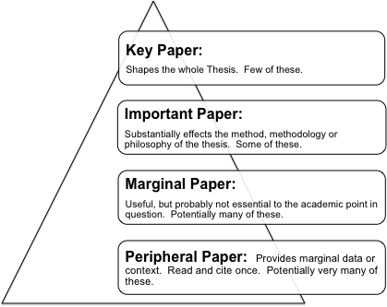

Hutchinson, Lawrence and Filipovic Carter (2014) Enhancing the Doctoral Experience – a Guide for Supervisors and their International Students (Gower)
You also need to ask yourself:

- How long will this paper take me to read?
- How can I break this paper down to fit my concentration spans?
- How long will I ALLOW myself to take?
- Does this require full concentration or can I read it (for example) on a train?
- Do I need to print it out?

Tip – If you find reading on a screen hard then you may wish to use this STAGE to determine whether you need to print the document. For instance, you could print only the key and important papers, and keep low value papers on screen.

Ultimately, efficient readers make robust decisions about HOW they are going to read a document. They achieve this by understanding the purpose of the reading and by deciding which parts of a document are worth full attention.

Section 3 | Habitual Consistency

Building a set of effective and efficient habits
At the start of this guide we addressed the questions of what reading habits you have that particularly help or hinder your effectiveness. This section builds on these questions and suggests ways to enhance your notes and processing.

There is no ‘right way’ to take notes from an article or chapter. You should find and refine a consistent system based on a number of questions. Such as:

- Is the article in question of substantive value to your thesis? If so you should be processing and making notes with greater depth and thoroughness.

- Will you need to return the original article in the future because you can’t understand or read your own notes? (Of course you’ll have to revisit some source materials – it’s called RE-search for a reason – but this shouldn’t be because your processing was sloppy).

- Is your note-taking consistent and streamlined? For instance you may find it helpful to develop a coding system like:

Major Point | Solid ring
Secondary Point | Solid underline
Tertiary Point | Dotted underline
Quotation | In brackets
A logical sequence of points | Numbers (i.e. 1,2,3)
Agree / Disagree | A / D
Exciting / Contentious | !/ *
Unclear- don’t understand | ?
Follow this up | $

Finding, refining and sticking to a coding system can make the routine elements of notetaking more efficient and leave space and time for your other notes. You could also apply this notion to using different colours (either using a good PDF reader or a multi-coloured pen) to annotate different types of information. For instance:

Black | Relating to data
Red | Relating to your critical opinion of the work
Blue | Relating to the author’s process of obtaining data
Green | Idea / Insight

You may, after processing the paper, wish to ‘translate’ what the author has said so as to recall and use it more effectively later on. Translation can take a number of forms – which you choose should be informed by personal preference and the value of the article in question. Methods for this intellectual translation could include:

- Graphical Mapping – MindMaps, Concept Diagrams, Flow Charts etc can all offer different value to help you intellectually capture an author’s ideas and arguments.

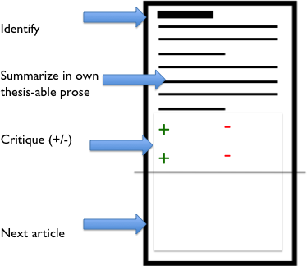
- ‘Thesis-able Prose’ – Lots of academics (this author included) use a system by which they
‘translate’ the valuable elements of the paper they’ve read into prose that could be used in their own thesis / papers. How much they write depends on the value of the paper and which elements of it the note-taker wishes to use. (Somewhere between 2-3 lines and one page is sensible.) Underneath this translation they may also note their own critical opinions
about the source text. Of course, as we intellectually evolve our critical opinions of a text may change; but crucially the thesisable prose (a journalistic record of what the original author has said) will not. All literature notes can be stored in a single file (or thematically grouped) and can then be retrieved and used in the academic writing phase of research. Engaging in this process while the source material is still fresh in the mind minimizes accidental rework months or years later.

- Standardised Note Proforma – Creating a proforma (such as the template presented here – adapted from Wallace and Wray (2006)) can provide a consistent repository for your critical notes.

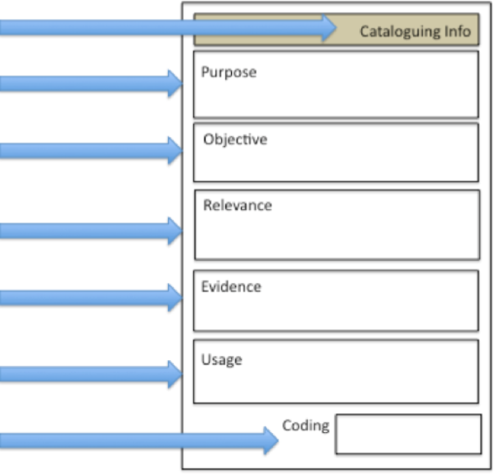
Catalogue Information (i.e. Author, Title, Date,
Journal, Page etc) Purpose – Why did I read this?
Objective – What were the authors trying to do?

Relevance – How valuable is this to my research
question?

Evidence – What is the quality of the evidence
presented? Usage – How can I actually use this text?
Action Code
- Return to this for detailed analysis
- An important general text
- Of minor importance
- Not relevant

Section 4 | Criticism and Comprehension

Building a rigorous intellectual toolkit
At post-graduate level or above, it is vital that you hone your critical skills. You may wish to look at the sources cited at the end of this document, and you may even wish to take an advanced module in critical thinking – the better your thinking, the better your research will be.

Comprehensive Processing
In section 2, at the first STAGE of reading, the notions of Purpose, Predictions, and Questions were discussed. These elements will certainly help your reading comprehension. In addition to these, you may wish to consider:

Cover / Title / Author (anything “pre” content)
What information is the author giving you about the content? What does the title suggest? Why did they use this particular graphic on the cover? What do you already know about the author’s style and approach to scholarship?

Table of Contents / Skeletal Structure
These are the map and signposts that the author provides to guide the reader’s comprehension.

Glossary
Are there any new terms or labels that you can front-load?

Introduction / Preface / Abstract
Here the author provides guidance as to what they consider the primary value of the article to be.
Also, after each section of a document, check your comprehension by asking yourself whether you can VOTE:

Value – What value does this section add?
Opinion – What do you think of what the author is saying?
Translate and Explain – Can you extract the author’s core messages and convert, translate or explain them to another party.

Critical Processing
Regardless of the way in which you take your notes or process more generally you should always be paying attention to:
Provenance – is the evidence appropriate in its source, quantity, quality and probity?

Objectivity – is the article balanced in terms of the arguments and counter-arguments it presents?

Persuasiveness – how close to factual ‘truth’ are the author’s conclusions?
Value – how much value to your thesis (and more widely) does this article add? (Ask ‘so what?’ after you’ve read something!)

Some academics use a set of questions to guide their critical thinking process. The list below is not intended to be exhaustive (or unilaterally appropriate to all intellectual disciplines) but it may get your thinking started.
Does the author formulate a relevant problem/issue? Is it clearly defined?

Could the problem have been approached more effectively from other perspectives? What value does this source actually add? What are its strengths and limitations?
How good are the basic components of the study design (e.g. validity, reliability etc)?
If appropriate, what is the author's theoretical framework (e.g., psychological, developmental, post-modern)?

Is the author's perspective objective and balanced or biased?

What is the relationship between the theoretical and applied perspectives?

How does the author structure the argument? Can you "deconstruct" the flow of the argument?
Has the author evaluated enough literature relevant to the problem/issue? Does the author include literature taking opposing positions?
Is the analysis appropriate? Are the conclusions justified?
Are the conclusions validly based upon the data and analysis?

How valid is the impact of this work? (Does it answer the “So what?” question)

Are the author's arguments and conclusions convincing? Does the work ultimately contribute in any significant way to an understanding of the subject?

How does this book or article relate to the specific thesis or question you are developing?

The framework above is adapted from a number of sources, including:
Hart,C. (1998) Doing a Literature Review: Releasing the Social Science Research Imagination Sage Publications
Hart, C (2008) Searching and Reviewing the Literature and Information Skills in The Postgraduate Handbook Edited by Ged Hall and Jo Longman Sage Publications
Wallace, M. and Wray, A. (2006) Critical Reading and Writing for Postgraduates Sage Publications

Section 5 | Rapid Reading

Techniques to increase your reading and intake speed
There are a number of tools that rapid readers use to increase their reading speed. However, care should be taken here – since books and web-material on the topic of speed-reading is aimed at native-language speakers who are reading non-academic texts and who don’t have to intellectually ‘use’ the material that they read.
If these strategies below seem interesting, then start on simpler material at first and gradually escalate the complexity of your reading material.

Efficient reading techniques don’t make you cleverer. They simply sharpen your intake mechanisms. If you can’t understand a text when you read it slowly, you won’t be able to when you read it quickly, will you?

Speed Reading Element One – Baseline Data
Read a simplish (broadsheet newspaper will do for starters) text on paper or screen at your ‘normal’ speed for one minute and calculate your read speed in words per minute. This is your baseline level. (Wait a minute or two and then consider your comprehension level of what you’ve just read.)
(NB - Most native speakers tend to read at approximately 250 words per minute. After extensive practice (and on simplish texts) effective speed readers can comfortably reach 4-5 times this speed.)

Speed Reading Element Two - Get Warmed Up
Before you read something take a few seconds to pause and concentrate. Find a physical environment where you can actually focus and get your mind right.
Look at an object in the middle distance and then close your eyes for a few seconds. (In effect this is akin to some light stretching before you exercise.)

Speed Reading Element Three – Push Yourself
Once you’ve warmed up, read for another minute as fast as you can whilst keeping your comprehension level broadly the same as normal. Keep testing yourself in this way. (Ideally when you practice rapid reading techniques you should try to increase your speed while holding your comprehension level at a broadly acceptable level.)

Speed Reading Element Four – Identifying ‘Bad’ Habits
Read for a minute or two and note what is actually happening as you try to intake the information. Generally speaking, there are four ‘bad’ habits that are worth identifying and reducing. These are:

- Regression. Reading the same the same the same the same words or sentences again and again.
- Subvocalisation. Hearing the words in your head. (This will limit your speed to the speed at which you can talk.)
- Lack of focus. The sudden intrusive thought about what you’ll have for lunch is very damaging. You lose focus (and regress) more if you are tired.
- Academic Drift. When a legitimate academic thought crops up, or a reference appears that you simply must follow. This is obviously important, but in a way also distracting.
Tip – If something occurs to you, place a dot in the margin, and then continue to read to a sensible break in the text and then revisit the dots. (Often a dotted point will have been explained by the author in a later sentence.)

Speed Reading Element Five – See Bigger Pictures
The eye has a pretty narrow focal range and so moves continually to get a clear image. In effect it captures a still image a few times each second and then fills in the blank. If you practice seeing more words each time your eye captures content, then instead of this:


Essentially, what you get is:


Practice reading two words at a time. If you were already doing that, add two extra. Then try three words at a time. If you were already doing that, add three extra. Practice for a short time and then redo the one minute read.

You may find that initially your comprehension starts to drop. Keep practicing. Try using the punctuation to help (i.e. see to the comma, see to the full-stop).
An additional advantage of grouping words like this is that it reduces subvocalisation.

Speed Reading Element Six – Keep Going Forwards
Think of yourself like a shark that has to keep swimming forwards. Force yourself (in practice) to simply keep reading forwards with no regression or back-skipping permitted. (In effect this is what happens when someone talks to you, and your comprehension
doesn’t suffer because they only say things once.)

Speed Reading Element Seven – Reduce Subvocalisation
In practice, read for a minute at a fast but comfortable speed. All the time that you are doing this, say a short word (in your head) repeatedly and continually.
“and.and.and.and.and.and.and.and.and.and.and.and.and.and.and.and.and.and.and.and.a nd.and.and.and.and.and.and.and.and.and.and.and.and.and.and.and.etc.”
In effect this ‘jams’ your audio-channel so you can’t subvocalise. In relatively short time you’ll start to depend on your inner-voice less and less.
Tip – If this process is too detrimental then try hearing only the key words and gradually reduce your dependency.

Speed Reading Element Eight – Use a Pacer
Ask a friend to ‘make a circle with your eyes’ and what you’ll see isn’t circular. It will have angles, straight lines and be probably quite jerky. But if you trace a circle in the air with your finger and ask them to follow this with their eyes you’ll see their eyes describe a much smoother path.
Effective rapid readers will usually have a motile pacer .Try out different guides – your finger, a pen, a file card, a ruler. If the movement of the pacer is distracting, try running your finger down the margin.
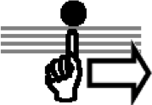
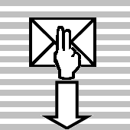
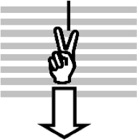


Keep an even motion - don’t pause or stop. At first, don’t try too hard to read – just find a “pacer” that feels comfortable to you. Remember that the eye should follow the finger and not the other way round. Gradually increase the speed of the pacer.
Tip – If you read a lot on a computer screen an old-fashioned mouse style pointer makes an excellent pacer.

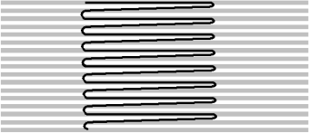
Speed Reading Element Eight – The Lazy Z
As you improve, you’ll notice that you are relying less on the focal pacer and your peripheral vision is capturing the content towards the margins. Like this:

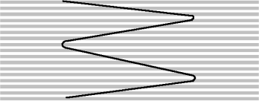
The next step (over time) is to widen this coil. This shape is sometimes referred to as a “lazy Z”. Like this:
Of course, if what you are reading in primarily formatted into two narrow columns (as most academic journals are) then this narrowing of the coil is far easier to achieve.

Speed Reading Element Nine – Practice Makes Perfect
Over the course of a few weeks (ten minutes a day) practice the above techniques and gradually escalate the ‘difficulty’ of the text, by including denser texts and higher degrees of academic complexity.
Don’t simply try the above techniques with dense, intellectually demanding prose that your boss is going to grill you on the next day. You need to walk before you can run.

References
If you want to learn more about speed reading, you may find the following texts offer helpful tips and advice:
Buzan, T. (2009) The Speed Reading Book BBC Consumer Publishing Chambers, P. (2013) Brilliant Speed Reading Pearson Ed
Kump, P. (1998) Breakthrough Rapid Reading Prentice Hall

Other books are available, and a quick trawl on Amazon will reveal many.

There is much software on the market that aims to help people read more quickly. The below are not recommended, but you may wish to have a look at:
Spreeder http://www.spreeder.com

Spritz http://www.spritzinc.com/

There are also many free open access speed reading apps and packages available to download.

If you want to hone your critical skills, try:
Hart, C (2008) Searching and Reviewing the Literature and Information Skills in The Postgraduate Handbook Edited by Ged Hall and Jo Longman Sage Publications

Wallace, M. and Wray, A. (2006) Critical Reading and Writing for Postgraduates Sage Publications
Williams, K. (2014 2nd Edition) Getting Critical Palgrave Macmillan Pocket Study Skills

