The Writing Process:

Getting Started
Online Resource



This online guide was developed by Dr Mimo Caenepeel, Research Communication Scotland and is designed for all Postgraduate Researchers getting started with Academic Writing

- Writing and expectations

- Developing fluency

- Exploring form

- The first draft

- Post-drafting



Writing and expectations

Writing a dissertation means working with complex content. The input for an academic text comes from many directions: ideas, research, reading, notes and thoughts. Academic writers need to absorb, distil, organise and articulate this input into sentences, paragraphs, sections and chapters. The resulting text will need to find a place in an academic environment with high standards and expectations.

It is particularly when we start to write that we feel the weight of these expectations most acutely: there is so much to think about, and so much that is vulnerable to criticism. It is no wonder, then, that when we plan to start writing, we often find ourselves doing something else instead — something that is more straightforward or makes us feel more at ease.

You will probably be familiar with those times when instead of starting to write (as you planned to), you find yourself reading another article, replying to email, clearing your desk or cleaning your fridge. Finding refuge in such ‘anti-tasks’ is much more comfortable than starting to write, and often we do so with a sense of optimism that starting to write tomorrow will be easier. Unfortunately, that rarely turns out to be the case.

Even when you manage to resist the lure of anti-tasks and start to put your thinking in writing, you may be preoccupied with meeting the high standards of academia. Such a preoccupation manifests as re-reading, erasing, correcting and changing words and sentences more or less as soon as they appear on the screen, in a continuous attempt to improve them and ‘get it right’. It’s as if a critical eye is scrutinising your every move. This is stressful; in fact, it may be so stressful that your draft simply refuses to be written. If you have ever found yourself in a loop of starting, backtracking and restarting, you will have been ‘stressing out’ the draft you are trying to write. And every time you do this, unsurprisingly, your resistance to writing will grow.

The alternative is to approach your first draft merely as a way of making visible, to yourself, what you are trying to say, without worrying about what it looks like (yet). In other words, you ‘shrink’ the expectations around it. You will still do all the work necessary to ‘write well’, but you distribute it differently: you bring some of it forward (before the first draft) and leave some of it till later (after the first draft). In other words, the first draft becomes no more than a step in a longer process that eventually culminates in writing well.

A simple way of representing this process is as a stair that you climb one step at a time:
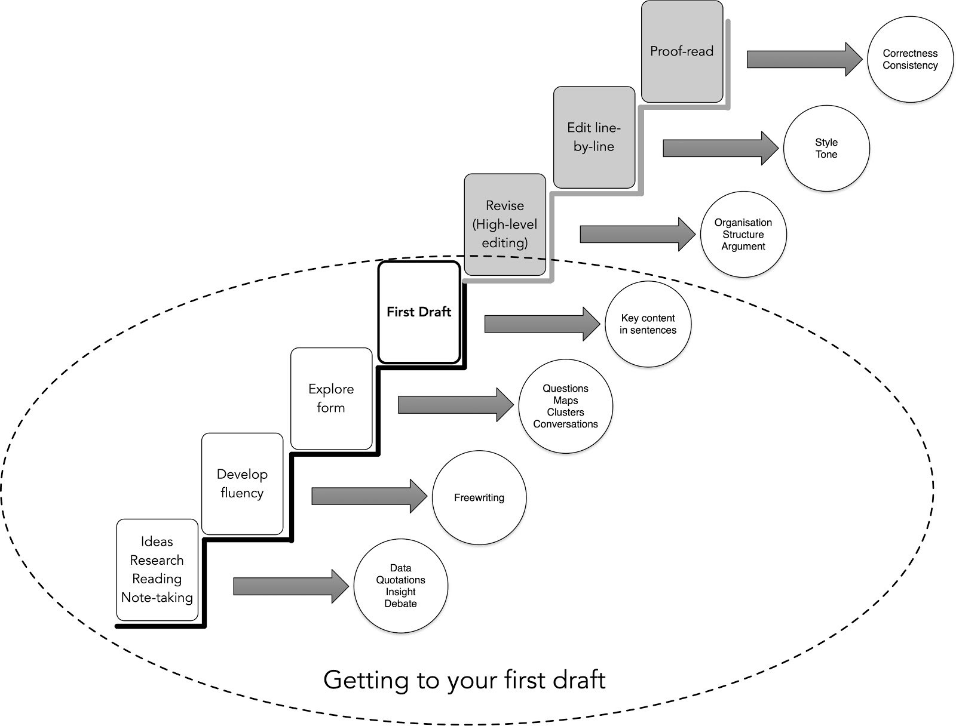
This metaphor has its limits, of course (like all metaphors), because it does not capture the iterations and returns that are an inevitable part of the process. A branching staircase with spirals, ups and downs (and resting places) might be more apt:
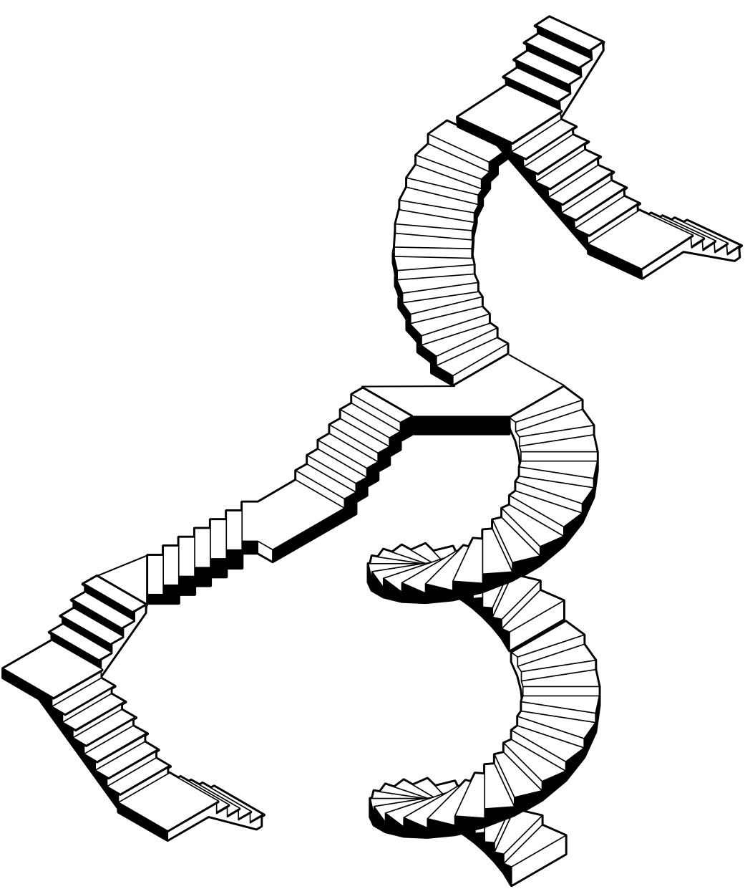
The main point is that ‘writing’ does not start (or finish) when you sit down to compose sentences. Alastair Fowler captured this memorably when he stated that ‘the best way to begin is not to. Or rather, to have already begun.’ (Fowler, 2006) If your first draft is a continuation rather than a leap, the task becomes lighter; your resistance to writing will diminish and anti-tasks will be easier to resist. An ‘unstressed’ first draft is an achievable goal.

This resource focuses on some of the writing work that precedes and prepares for the first draft. It will ignore parts that will already be familiar to you (research activities, reading and note-taking) because most researchers are pretty diligent at those. Instead, this document focuses on two early-writing, pre-draft activities that are often neglected: ‘developing fluency’ and ‘exploring form’. If you find it hard to get started, you probably tend to skip at least one of those. What follows is a brief explanation of what they mean, why they matter and how you can include them in your writing process.

Developing fluency

Freewriting
‘Fluency’ refers to the capacity to write about your discipline, your research and your thinking with relative ease and a focus on content. All good academic writing relies on this capacity, but it does not arise out of the blue. Writing about your subject and research takes practice – the practice of writing with the aim of expressing (saying what you are trying to say), rather than impressing (by saying it correctly, concisely, academically...).

Your tool for this practice is freewriting. Freewriting has a long history (e.g. Brande, 1991 (1934)) but it was first and most influentially applied to academic writing by Peter Elbow. Elbow, a US-based academic, experienced great difficulty when he started writing a PhD, so much so that he dropped out in the first year of his doctoral studies. He attributes his eventual successful completion of his doctorate to the fact that he learned to put words on the page without immediately evaluating whether they were ‘the right words’. Elbow realised he could only achieve this by writing without stopping, because as soon as he stopped writing, he would get caught up in correcting the ‘wrongness’ of his words and sentences (Elbow, 2000).

Elbow’s main insight is that the practice of writing freely is fertile ground for early drafts that lead to accomplished drafts. Over the past decades, this has become a key tenet of some prominent approaches to academic writing (e.g. Bolker, 1998). It has also, at times, been misunderstood or over-generalised, due to a confusion between freewriting and writing an ‘outcome’ text. Freewriting is not a substitute for the larger, time-consuming process of producing an accomplished piece of writing; rather, it is a practice that enables and feeds into that process.

Freewriting to prompts
Freewriting means writing without editing; its ‘freedom’ lies in bypassing the ‘inner editor’. Most academics (including PhD students) have powerful inner editors to protect them against criticism. For many, the only way to bypass this editor is to write without stopping. The moment you stop, your editorial eye will spot things that are not up to scratch and you will feel compelled to change them. This will interrupt the flow of your ‘thinking in writing’, and shift the focus from content and flow to a critical assessment of how that content is expressed. That critical assessment is important, but only once your thinking has had a chance to land on the page or screen.

Freewriting trains in uncoupling writing from the relentless scrutiny of our inner editor by keeping your hand moving on the page or keyboard, allowing your thoughts to appear on the page or the screen as they arise. Freewriting works best if it is done for short periods on a regular basis – time periods short enough for you to commit to even if you slept badly, are not in the mood for writing and have a busy day. For most people that means 10 or 15 minutes, at least to begin with. You can increase this over time in small increments; you will know when you have been too ambitious when your resistance kicks in and you find yourself doing something else.

In the context of research writing, freewriting tends to be more productive and focused when you start with a new prompt every time (Boice, 1990) (Murray, 2006).

Prompts are half-sentences that invite continuation, elaboration and exploration. They can be general:
- I need to understand better why/how/what …
- In yesterday’s supervision, Davina emphasised …
or specific:
- X’s definition of Y is important for my research because …
- My perspective on Y is different from X’s because…

Prompts work best if they are tailored to your current thinking, reading or research activities –– that is, on what you need to clarify or articulate at the time. Don’t overthink them: work with what comes to mind or what is most ‘alive’ for you. If you commit to freewriting on a regular basis you will find that, over time, prompts will become part of your research management, encouraging you to reflect on, and articulate, what you need to explain to yourself or understand better.

When your alarm goes off at the end of a freewriting session, you can ‘park on a downward slope’ by setting a new prompt. This will make it easier to start the next day because in a small way you have already begun.

Challenges and benefits
Freewriting once in a blue moon is not going to have much impact on your writing. To experience its benefits, you need to make a small but consistent commitment. This can be a challenge for some people. The other challenge is that freewriting won’t produce text that is up to academic standards. That can be hard for researchers who, as Rowena Murray puts it, long to produce ‘fragrant’ writing (‘writing well’) but instead find themselves producing ‘manure’ writing (‘writing badly’) (Murray, 2006) instead.

The benefits of freewriting are well-documented. Regular practice encourages you to think on the page in a down-to-earth way that keeps you focused on the first requirement for good academic writing: producing content that you understand well enough to articulate it in your own words. Freewriting supports drilling down and exploring the detail of your thinking, because you won’t get sidetracked by trying to impress or dazzle. It builds writing muscle (both literally and metaphorically), familiarises you with your ‘writing voice’, and breaks the counter-productive association between writing and worrying. The habit of freewriting can be particularly helpful for non-native speakers who want to increase their capacity to write about their research in English.

Should you look back on your freewriting? The short answer is yes, but with the appropriate mindset. Revisiting it will tell you all kinds of things. You will notice that some of your ideas have a fresh, original or well-articulated quality, and that there are some things you keep coming back to. These are the parts you want to highlight and move to another document which you keep nearby when you draft. Other parts will make you cringe; yes, that’s the ‘manure’. Relax with the un-noteworthy, low-achieving, dull parts of your freewriting; they are just part of the process.

Rereading your freewriting on a weekly or fortnightly basis is a good rhythm for most people.

Exploring form

The final, ‘endpoint’ form of your academic writing will need to reflect which statements belong together; how some logically lead to others; how some parts will be more general, and how others expand into detail; how some will come first, and others later; and how your text progresses towards a conclusion. That means you need to make a lot of decisions when you build a text.

If you try to make all those decisions in your first draft, your draft will quickly become stressed. Where to begin? How to continue? What goes where? The alternative is to explore some of the ‘form’ of your thinking before you draft, and revisit the form afresh once you have a draft.

Seeing a potential way of shaping your content will ease the transition into drafting. The best way to do this is by starting with questions, the dynamic roots of research, and go on to map content and relationships.

Questions
You may think of your research in terms of a ‘topic’. That can be helpful in the early stages of a PhD. Unfortunately, topics tend to become stretchable and unboundaried — in other words, easy to get lost in.

Research is not propelled by topics but by questions. Questions emerge from problems, gaps, or limitations of existing work. Questions generate energy and focus because they arouse curiosity and invite answers. All this makes them a good starting point to explore the form of your thinking.

Here is how to generate a potential form from questions.

Start with the question that drives the text you are working towards, and write it down as a full sentence with a question mark at the end. Next, generate as many questions as possible that are related to this driving question. Drill down; make some of your questions detailed or specific. Do this for at least 10 minutes, until you have at least 10 questions.
Next, explore which form emerges from your list of questions.

The most basic aspect of form is scope. *Star questions you will address in your envisioned draft; [bracket] ones that you won’t address because they would take you too far. Continue by looking at the position of, and relationships between, the questions within your scope. Which questions are central and which ones are more peripheral? Which ones are more general, which ones are more detailed? Which ones sprout from others? Connect questions that belong together, and mark how some questions break down into others.

Your question landscape will be rough; that’s OK. Set it aside for a while before you move on to the next step.

Maps
Some writers prefer to draft without a map, in the way that some walkers prefer to follow their nose and develop a sense of territory as they proceed. However, most academic writers find it a lot easier to draft when they have some kind of map that captures key concepts, main points, core connections and some detail.

Mapping is a way of thinking on the page without being constrained by sentence building, which is why it can be a welcome alternative to (and preparation for) writing text. By activating the non-verbal parts of our minds, maps can reveal previously unspotted possibilities and relationships.

There are many ways of mapping. You can go old-school and work on the page, in black and white or colour, with pens and crayons. You can map on your screen, online, on your laptop or i-pad, using software resources like Scapple (literatureandlatte.com), Coggle (coggle.it) or Freemind (freemind.sourceforge.net). You can find inspiration in Sketchnoting (Rohde 2012) and develop your own way of creating maps.

Irrespective of your preferred style and technology, you need to keep words to a minimum and rely on shapes (lines, branches, arrows, squiggles, balloons, squares, etc.) to reflect the shape of your thinking. Map until you have occupied your page or screen in all directions.
Pre-writing with maps is similar to freewriting in its unworried quality. Your thinking will clarify but it won’t be tight. You will capture forms, focal points and relationships, but without finality. You are working with vision and potential rather than an endpoint or ‘getting it right’. You may draw up more than one map. A more peripheral part of one map may become the centre of another one.

For some writers, a ‘spatial’ map provides enough form to start drafting. Others need to see potential linear progression before they transition into a draft. You may want to experiment with tracing a path through your map, relying on aspects of academic structure to find it. What is ‘given’ (shared background), and what is new (contribution)? What constitutes substantiation or evidence that will shape your argument? What is your endpoint? Once you have a sense of sequence, you might want to annotate it with key observations, statements, references or relevant detail. You may want to sculpt all this into a detailed academic outline before you start drafting.

Some writers need more freedom to draft, others need more form. Accommodate the kind of writer you are.

First draft!

In your first draft, you begin to express your ideas, thinking and findings in sentences; you start building a text that will be read by someone else. This makes it different from freewriting, where the only expectation was to show up and write. But if you have taken pre-drafting seriously, drafting will be less stressful: you will already have articulated content and explored form, and your writing muscle will be strong.

Even so, you may experience anxious or unsettled feelings as you make the transition into ‘product’. There are two ways of dealing with this. The first one is to keep in mind one of Hemingway’s best-known (and best-loved) statements: “The first draft of anything is shit”; the second one is to play to your strengths.

The first draft of anything is sh*t
“The only way I can get anything written at all is to write really, really shitty first drafts,” says Anne Lamott (Lamott, 1995). Many other authors adopt a similar ‘in-your-face’ terminology to make sure we don’t confuse first drafts with endpoint writing: first drafts are ‘messy’, first drafts are ‘ugly’. Paul Silvia captures this more humorously when he says that first drafts “should sound like they were hastily translated from Icelandic by a non-native speaker” (Silvia, 2007).
The key message is that a bad first draft is a good place to start. First drafts tend to be uneven, with some parts more expanded than others; they won’t be articulate and elegant. Almost all first drafts use many more words than are necessary, and all first drafts need more work. That work will be an iterative process of checking, rereviewing, changing, expanding and contracting.
All that will be workable because your bad first draft has been written. That’s much better than a good first draft that didn’t get written. A first draft that exists can be taken forward, one step at a time, towards the final version.

Play to your strengths
Some authors find it easy to fill pages that are high on word count but untamed in terms of structure. If that’s you, take the spirit of freewriting into your first draft and run with your words. Building momentum will come naturally to you; you may lose sight of your map and find yourself writing for long stretches of time, producing a first draft that feels chaotic and cries out for paragraphs, sections, structure. Such a draft is workable, which is all you need.

Some authors naturally find form and structure but writing prose can feel like wringing blood from a stone. If that’s you, rely on the form of freewriting to compose your first draft. Build as detailed a structure of your thinking as you need; this may be a full academic outline.
Then, commit to 15 minutes of drafting components of this structure each day, and rely on this repetition to build momentum. Your early drafts may feel tight and clunky. That, too, is workable, and all you need.

Post-drafting

Once your first draft has been born, you will feel a strong urge to improve it, to help it progress and ‘grow up’. That’s understandable. But first of all, you need to put your draft aside. Let it cool. Close familiarity with your draft will impair your editorial skills.

Defamiliarising yourself from your text by doing something else will sharpen your editorial judgement. Maybe all you have time for, in terms of a pause, will be the time it takes to have a cup of tea; or maybe you will go and climb a couple of Munros before you return to your text.

When you return to your draft, you will improve it by re-organising and revising it, incorporating feedback, editing line-by-line and eventually proofreading. As you go through these stages, you will be thinking deeply at times, and obsess over surface features of your text at others. You will be working with rules, conventions and intuition.

Your first draft will feel like long ago and far away when, at some point, you realise you have written well.

References

Boice, R., 1990. Professors as Writers: A Self-help Guide to Productive Writing. New Forums Press.
Bolker, J., 1998. Write Your Dissertation in Fifteen Minutes a Day. Macmillan.
Brande, D., 1991. Becoming a Writer. J.P. Tarcher.
Cameron, J., Bryant, M., 2016. The Artist’s Way. Blackwells.
Elbow, P., 2000. Everyone Can Write. Oxford University Press.
Fowler, A., 2006. How to write. OUP.
Lamott, A., 1995. Bird by bird: Some instructions on writing and life. Anchor.
Murray, R., 2006. How to Write a Thesis. Open University Press.
Silvia, P., 2007. How to Write a Lot: A Practical Guide to Productive Academic Writing. APA Life Tools.

This online guide was created by Dr Mimo Caenepeel,
Research Communication Scotland

