Graphical Note-

Making and Mapping for Research
An Online Guide

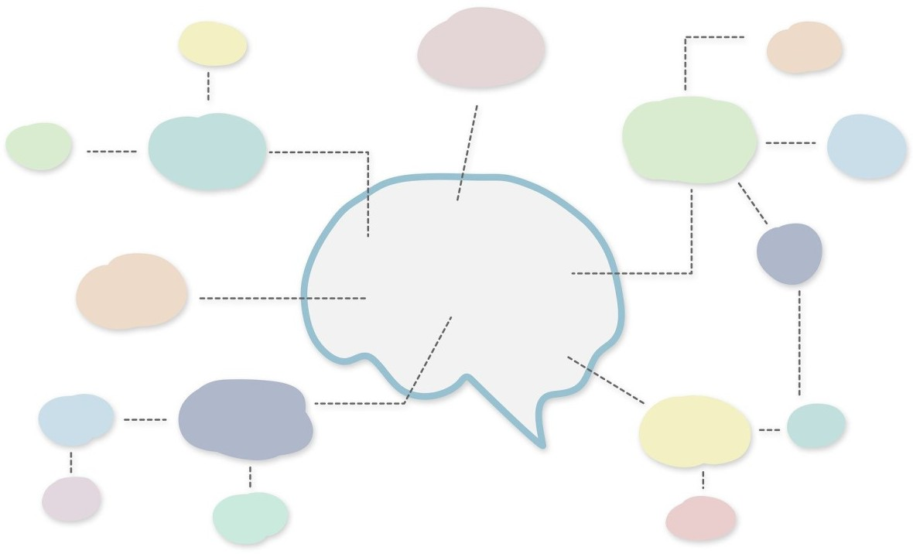



Contents
- Introduction and Disclaimer
- Know Your Purpose - Different tools for different jobs
- Knowing yourself and Mapping ‘Naturally’
- Functions of Mapping for Creativity and Memory
- Maps – So, what are they?
- Software and Apps for Mapping (mApps?)
- Getting Started in the ‘Right’ Way
- Structural Understanding
- Prioritization
- Putting It All Together
- Taking It Further
- Further Readings
- Mapping as a Tool for Qualitative Research

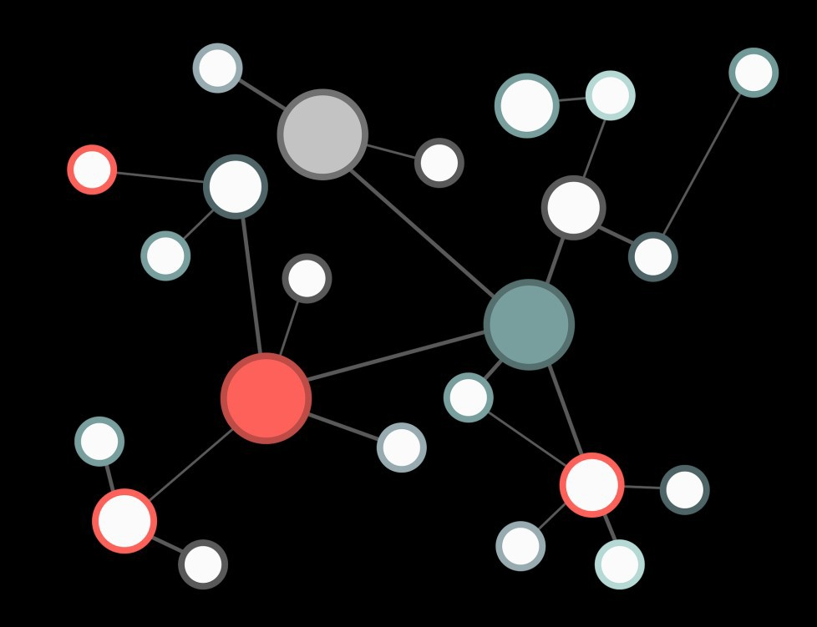

Introduction
As researchers, our chief currency is information. We must be able to store it in ways that are meaningful for us, we must be able to recognize what is important inside it, and yet we must also be able to identify new connections, new patterns and new forms within it.
As such, many researchers (and professionals who have to think and identify links and conceive new ideas) use graphical mapping as part of their toolkit.
They use it as a way of capturing meetings, preparing presentations, writing articles and assignments and planning large scale creative projects. It is also recognized as a valid research data-capture tool in and of itself.

This short guide will provide you with some tools, tips, links and further reading to help you manage your thoughts and information, and hopefully to come up with some new ideas.
There are number of Tasks (in boxed sections) throughout this guide, and you may need some stationery to complete them:

Blank Paper (at least A4, but A3 or flipchart gives more space)
3-4 coloured felt tip pens / or a multi-colour biro and a highlighter

These tasks will seem simple at times, but they are worth doing. Mapping is quite a simple thing to do, but people can find it very difficult if they don’t grasp the basic principles or process their information in the ‘right’ way.

DISCLAIMER

Where relevant, this guide will also provide links to interesting further reading, but it’s primary focus is quick pragmatism, as opposed to an in-depth study of a tool and any of its underlying (cod) psychological or neuro-scientific principles. To that end, it must be noted right from the start that the practices and rationale of MindMapping (as a definitive tool) draws mixed academic findings as to its effectiveness compared to the claims that some non-academic experts claim for it.

This guide aims to help practitioners to adopt mapping and graphic organisation of information as a PROCESS and makes no claims as to the accelerated learning or enhanced memory-building properties of any given PRODUCT.

Know Your Purpose - Different Tools for Different Jobs
Before we start on graphical mapping as a toolset it is worth us taking a pause and reflecting on whether the tools we currently have are effective. For instance, do you have a separate tool for internalizing and externalizing information? Do you have different formats for Note-Making and Note-Taking?
NOTE-MAKING – Making a map or plan to help you process and EXTERALIZE your own new thoughts, thesis and ideas.
NOTE-TAKING – Taking information from an source, like an article, book or paper and helping you to INTERNALIZE it.

Task 1 – Examine your own ‘notebooks’ (either hard or soft form) and determine if there is a difference in the way you present information; either to EXTERNALIZE your own ideas, or to INTERNALIZE someone else’s.

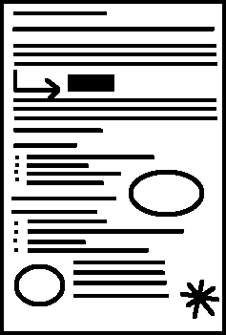
If the purpose of a tool is simply to capture a meeting or an article (i.e. logically INTERNALIZE information) as quickly as possible, then a set of well-taken linear notes with key elements highlighted or coloured might be appropriate. This is especially so if the overall structure of the source material isn’t made clear up front.
These notes can be made more effective by revisiting them after you’ve taken them and highlighting key parts and drawing in the links and other important features with colour and symbols.

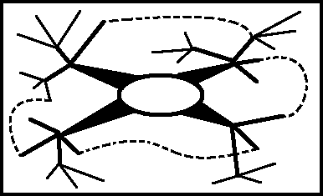
However, if the purpose of your notes is to show your new ideas (i.e. creatively EXTERNALIZE), the hierarchy of the information, the links and the overall structure, and to leave space around the edge to add new information as it becomes relevant, then a more radial form of mapped display might be far more appropriate.

With highly complex information, we need different tools for different jobs – so start by considering whether your existing toolkit is really fit for purpose.

Graphically mapping your information is designed to PRIORITIZE important information and to illustrate and help you to realize CONNECTIONS within it.

Know Your Mind and Mapping ‘Naturally’

There are a number of challenges that people face when they try to graphicize their information for the first time. One of these challenges is the self-held belief that they’re not a “visual thinker”, but the vast majority of people use their senses (including visualization) in the way that they process information. For instance:
Task 2 – Clear your mind. And then think about the following:
BREAKFAST
What has come into your mind?
You’ll probably have called up an image of a recent, or fantastic breakfast. Was it in colour or black and white? Was it moving or still? Was there background detail or an item simply floating in space?
(You’ll also probably get a similar richness of information that is auditory (the clank of a spoon or the crunch of the toast), olfactory (the croissant aroma) and gustatory (the taste of espresso) etc.)
What probably hasn’t come into your mind is this:

B . R . E . A . K . F . A . S . T
…and yet this word is the form with which conventional notes would aim to capture this multi-sensory event.
Back in 1949 a Canadian Neuropsychologist called Donald Hebb, known for his associative learning work, coined the phrase “neurons that fire together wire together.”

In other words, every sensation triggers thousands of neurons, which form a neural network. The more associations we have, the stronger the network. These associations are, of course, linked to all of our senses – not just the visual. However, graphic mapping of information aims to be visually stimulating to help strengthen the associative ‘net’. In short, it aims to be more ‘natural’ than linear, word-based, notes.

Further Reading:
Robertson, I. (2011) Mind Sculpture: Your Brain's Untapped Potential Penguin Books

Functions of Mapping for Creativity and Memory

It was once believed that the brain was a highly localized organ. Scientists believed that the left and the right hemispheres were distinct both in structure and function. This was known as hemispheric specialization theory.
It was thought that the Left (Logical and Rational) side of the brain was responsible for: LANGUAGE, LOGIC, NUMERACY, TIME, DETAIL, SEQUENCE, ANALYSIS.
While the Right (Creative, Intuition) side of the brain was responsible for

CREATIVITY, SPATIAL THINKING, CONNECTIVITY, RYTHMN, IMAGE, EMOTION, COLOUR, OVERVIEW
And, crudely, memories occurred when we cross-linked these two hemispheres. (Which is why we colour highlight (right) information (left) when revising for exams.
We now know that in reality it is far more complex than this, although it is still often taught as ‘fact’.
Further Reading:
McGilchrist, I. (Reprint 2010) The Master and His Emissary: The Divided Brain and the Making of the Western World Yale University Press
See also related web material - (Google Search - RSA Animates Ian McGilchrist)

However, for a researcher whose success is based on ‘original thought’, maps offer an effective way of connecting different function areas which can aid memory and spark creativity.

Ultimately, even if you decide that mapping is not for you, it may be worth considering how might maximize your ‘creative’ functions as well as keeping the more ‘logical’ ones.

What Information do you Value?
In order to map effectively, it is also worth recognising how you, as an individual, typically process, categorize and sort information, and indeed realize to what type of information you are paying attention. You can gain insight into this with the following task:

Task 3 – Go to the nearest window and look out of it for 20 seconds.
Then, look away and without looking up, write about the view for one minute. This doesn’t have to be prose – any form is fine.
Now, study your writing.
Assuming you were in a University setting, some people will have gravitated towards ideas, concepts and metaphysical constructs; such as:
Campus / University City
Learning
Spring / Autumn etc Discovery / Potential
Other people will have written more about the physical objects and concrete items: such as: Man
Tree
Bench Car Birds
Most people have a mixture of these, but it’s worth noting the emphasis you place on either metaphysical concepts or concrete objects, since as scholars we need to be able to conceptualize big pictures and process little details. Your natural predilection one way or the other has implications for the way you map – and we’ll come back to this later.
Further Reading:
Briggs-Meyers, I. & Meyers, P. (1980) Gifts Differing Davies-Black Publishing

Maps – So, what are they?
There are many different ways of expressing ideas and information in graphical form.
Task 4 – Look up the following terms, as image searches, on Google or similar search engine. Concept Map
Spider Diagram Mind Map
Brainstorming Idea Chart

You’ll notice a high degree of overlap between these types of map and infographics. There are many terms that are used erroneously and interchangeably, but these tools share similar elements. All graphic mapping approaches generally share a handful of key components.
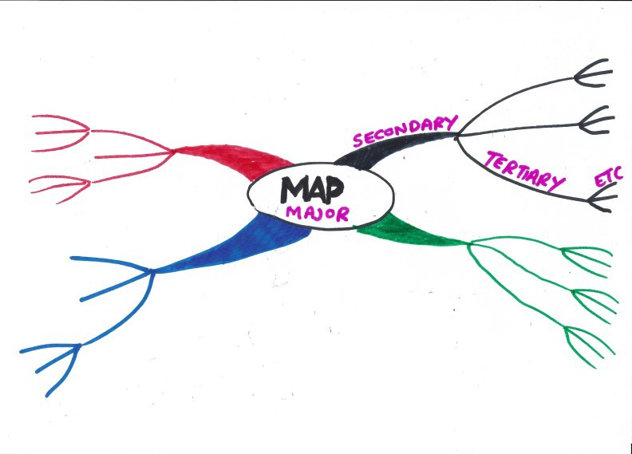
- Connectivity – nothing floats in space mentally. Psychologically, everything is neurally connected, and this connectivity should be reflected on the page.
- Concise – use capital letters and keywords – rather than script and prose.
- Radial – page is landscape and ideas flow from the centre outwards.
- Prioritized – more important elements are central and in larger font.
- Graphic – colour, icons, highlights, pictures – stimulating and creative.
- Organic – connections are shown, with a branched nodal structure.

Task 5 – Try it for Yourself
Pick a ‘simple’ topic, which contains room for exploration. For example: London / Edinburgh / Paris or another city
Holidays Career Music

Then try to map it out. You’ll need a few different coloured pens and a large sheet of (landscape) paper. Limit yourself to ten minutes.
When you’ve used ten minutes, ask yourself:

What form did I use and why?

What did I find difficult about this exercise?
What do I have at the centre of my map? Does this allow me to expand, or is it restricting me?
Where has the initial branching helped my thinking, and where has it restricted my thinking? If you were going to redraft it, how would you change it? What does this tell you?
Does my map reflect my insights as to whether I process metaphysically or physically (from previous section)? (For instance, if your initial associations are physical objects, you’ll have produced a very different style of map than if these associations are ideas.)
Here are a few tips that might help:
  - If you go back and look at examples on line you’ll notice that generally maps start at the centre with ideas (metaphysical) and radiate out to objects, things, and examples (physical). As such, it’s worth doing a little bit of thinking before you start to draw – a notion we’ll explore shortly – so that you don’t restrict your own thinking too quickly.

  - You’ll also notice that words are written on the branches, not in the nodes. (This saves space, and shows prioritization – the bigger the word, the longer the line it’s on!)
  - You’ll also see that lines are bent, so that you don’t need to turn the paper.

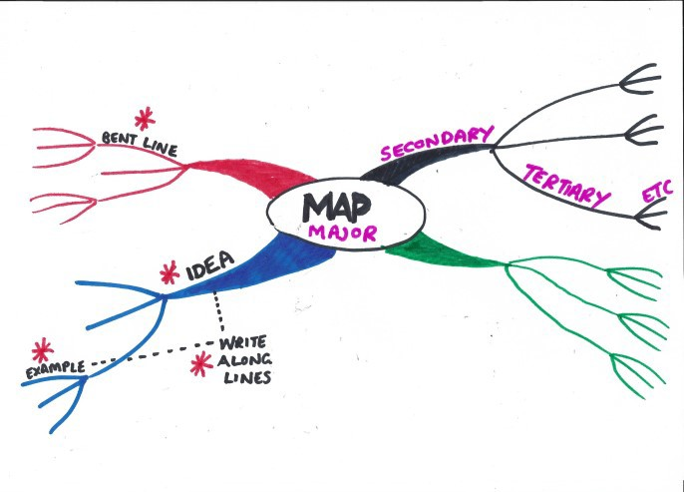

Task 6 – Deal with Reactions and Beliefs

Go back online and look again at examples of Mind Maps. List your reactions to them. What do you like about the form?
What do you dislike about the form?

How could you use the former elements in your work and change the latter elements so that they suit your needs?
MindMapping ® was developed by Tony Buzan in the 1970s following his research into note taking techniques. Buzan was a very influential author and champion of this graphical approach to notemaking. Obviously Buzan didn’t discover the psychological principles of this form of information presentation (central image, powerful colors, prioritization using size and proximity to centre, nodal structure) but he did put them together, give them a name and (cleverly) register the trademark!

Further Reading:
There are many books, ebooks and articles about MindMapping. You’ll notice they are all quite similar! Try the work of Tony Buzan as a starting point. For example:

Buzan, T. (2018) MindMap Mastery Buzan, T. (2009) How to MindMap

However, Buzan’s MindMaps (or interpretations of them) have a number of drawbacks that many researchers find problematic.
For a start, the nodal structure of a Mindmap means that once an idea is ‘on a branch’ it can’t easily be on any others. This is problematic in research where ideas tend to be very interconnected – in fact, more perhaps like a bowl of spaghetti than a neat radial diagram!
So, break this ‘rule’ and show the connections. Make it obvious where the overlaps are with clear ‘jumps’.

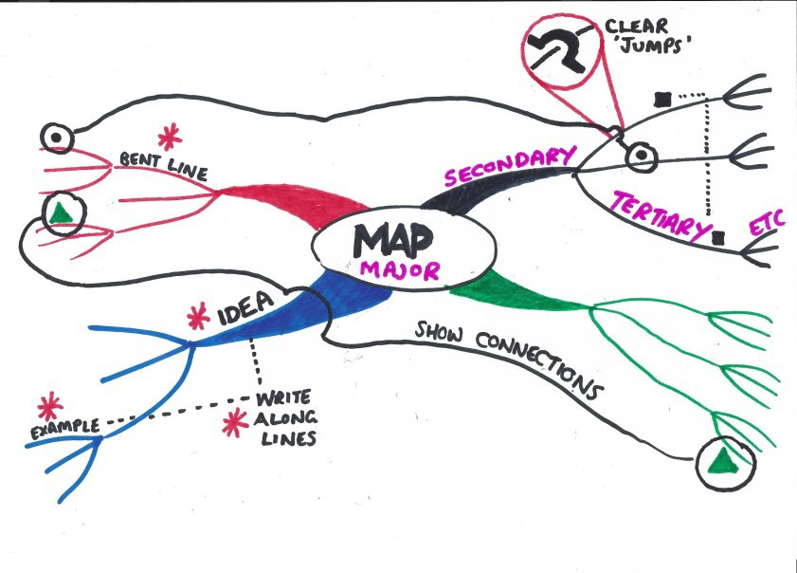
Secondly, MindMaps can look very ‘childlike’. This is, creatively, no bad thing per se – but whether you’d want to show them to your PhD supervisor in a serious meeting is another matter. This childlikeness be reduced with practice and drafting, but there is a reason why information for children is presented in colours and graphics and in a way that conducive to learning and memory.
Thirdly – some MindMaps look very, very, very beautifully artistic. Many people are put off by this beauty because they believe that they cannot draw as well, or that these polished artefacts would take far too long to construct. Most experienced mappers feel the same way too. But what they’ve realised is that the PROCESS of Mapping (for research) is the valuable part, not the PRODUCT.

The finished map PRODUCT may help aid memory and act as a scaffold for writing, but the mapping PROCESS of creating it actually adds more value. For instance, if there’s ‘mess’ on the page, then that may mean there’s intellectual mess behind it. Moreover, redrafting the map, and shaping it and working out where the gaps and confusions are is highly valuable PROCESS indeed.
Here are a few more tips that might help:
  - Using a whiteboard, or lining wallpaper, or flipchart (or simply post it notes and string pinned on a wall) create a map that builds over time. As new insight or facts become relevant add them to the map. Ensure that you leave plenty of space around the edges.

  - In a mapping session, work quickly and try to avoid judgement.
  - If adding colour and graphics are slowing you down, work in monochrome and add the stimulating elements in afterwards.

  - Use boxed sections or lists at the end of branches. This isn’t a technique suggested by MindMap purists, but can help if you get into very fine detail, or lists of information from a technical paper.

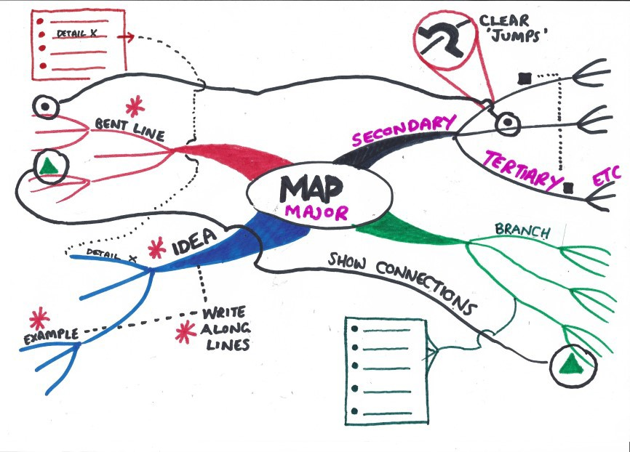

Bearing in mind that this tool is to help your thinking, and, as such, is simply evidence of a PROCESS, don’t worry about the so-called ‘rules’ of MindMaps. If it works and helps your thinking, then it’s good! To this end, it’s worth keeping a small notebook and multi-coloured pen about your person so you can capture ideas and thoughts about your work whenever they come to you.
You may want to practice your penmanship and technique, and so practice – one five minute map per day for a week – on topics that don’t have to be ‘correct’ (i.e. holiday plans, career ambitions).

Software and Apps for Mapping (mApps?)

While many mappers like the kinesthetic feel of pen and paper, there are some advantages of mapping using software. Such advantages include:
  - Collaborative possibilities – research teams can add to a shared document
  - Unlimited space – there’s no edge to the page
  - File Attachments – you can attach files to nodes and branches, and in effect create a visual index of your work.
If you don’t want to use paper and pen, you may want to investigate mapping software, as per these examples. Some of them are free and some cost. They’re all fairly similar, but have slightly different functionality. Others are available, but in alphabetical order, you could investigate:

  - Mindly (macOS, iOS, Android) (Mobile friendly)
  - Draw.io (Web, macOS, Linux, Windows, Chrome OS) (Free)
  - Freemind (https://sourceforge.net/projects/freemind/) (Free)
  - iMindMap (macOS, Windows, iOS) (Good for in-depth investigation)
  - LucidChart (Web, iOS, Android) (Radial maps into a flowchart)
  - MindGenius (Often supported by Educational / University software offerings)
  - MindManager (www.MindJet.com) (Good to show inter-branch connectivity.)
  - MindMeister (Web, iOS, Android, macOS, Windows) Good for teams.
  - Scapple (macOS, Windows) Really good for fluid mapping
  - SimpleMind (macOS, Windows, iOS, Android) cross platform functionality
  - SmartDraw (Web) for linear / business-style maps
  - Xmind (www.xmind.net) All round good package.

Regardless of whether you use pen and paper or software, it’s important to make sure that you are effective in the way that you map. So let’s explore a couple of ways that can help.

Mapping for Research - Getting Started in the ‘Right’ Way
It seems that there are two things that help researchers to map effectively from first principles. These things are Structural Understanding and Effective Prioritization of Information.
So, let’s examine them in turn.

Structural Understanding

Think back to when you spent a lot of your time in lectures. Think about the difference between a lecturer who simply rambled on and one who provided you with a clear structure up front (i.e. “today we’ll examine three main processes. Firstly,… etc”).

The lecturer who provided a scaffold and structure will have facilitated a better set of notes – regardless of how charismatic or entertaining they were. In order to process information effectively, we need structure.

One of the first thing that is clear about plots such as concept diagrams, spider charts etc. and especially Buzan-esque MindMaps is that they all have one central hub, out from which arachnid spokes radiate.

This single-centered hub approach can be problematic in research since many research projects concern the relationship between two existing ‘known’ topics – and the originality of the project is the uncharted interface. As such, one central hub can be problematic, bearing in mind that what is valuable for us is the PROCESS of mapping not the PRODUCT.
Task 7 – Identify Your Research Structure

Ideally, this is a task that you (reciprocally) carry out with a friend or colleague, but you can do it by yourself if you’re careful.

You need a large piece of paper (A3 to flipchart sized) and a fibre-tip pen.

For simplicity, assume there are two people participating in the worked example here. We’ll label them ‘Scholar’ and ‘Scribe’. The scholar talks, the scribe (with pen and paper) draws.
The scholar talks for five to ten minutes about the big picture of their research question and it’s sub-elements and how they connect – so that the scribe can capture it graphically. The
scribe asks questions to help them capture the overarching structure and relationships within the scholars work.
(You may wish to switch roles afterwards.)

After the time elapses, hand the map to the scholar and have them annotate the map, and discuss whether what has been captured accurately reflects the reality of their conceptual research schematic.

To help give an idea of what this exercise might result in, a couple of idealized hypothetical samples are presented here:
Example 1:

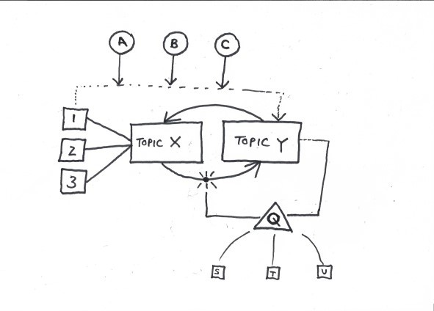
Scholar: So, I’m looking at the relationship between factors X and Y. We know that topic X has three major elements within it (1,2 and 3) and of these it’s number 1 that has the biggest effect on Y effect.
We think this is because of A,B and C.
Of course, there’s a block in the system (Q) which is made up of, we think, S,T and U.
Scribe draws→

Example 2
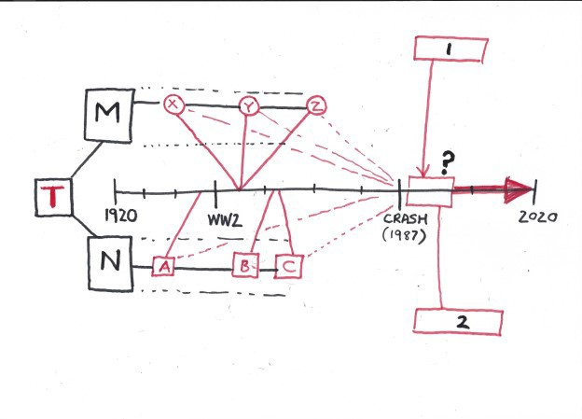
Scholar: Well, my topic (T) is an examination of the last 100 years, particularly with reference to sociological elements M and N – with
reference to how the reconstruction after the second world war was handled compared to the economic rebuild following the economic crash of 1987. M has a number of sub-factors X,Y,Z which can be seen in the late 1980s as so does N, and these are A,B and C. The primary sociopolitical in the 1980s are 1 and 2, and I’m really interested in how these were affected in the 1990s and beyond.

Scribe draws →

Now, of course, the reality of this exercise may well be very messy and unclear. But, as is always the case here, realizing the messiness is a useful part of the research PROCESS which neat lined prose would fail to illuminate.

Information Prioritization – First Isn’t Always Best

The second element of maps that often restricts peoples’ thinking is that they get caught up in their initial thinking. And our first thoughts aren’t always our best ones…

Task 8 – Take a blank sheet of paper and write down, in list form, the first 20 things you think about on the following topic;

SOCIAL MEDIA

Now examine your list. What are the first four or five things you wrote? Many people will start with the names of specific labelled social media platforms, for example:
- Twitter
- Instagram
- Facebook
- Linked In

If they’d done this exercise as a map they’d have filled the central (important) spokes with essentially very similar entities. Certainly there are differences between the listed platforms, but they are all essentially similar tools that allow people to do certain things.
Look further down your initial list about more, and you may well find those certain things. For example:
- Dating
- Friendships
- Connections
- Marketing
All of which give a research mapper interesting areas to explore.
Look further down the list, and you’ll probably find things on your list like:

- Security of personal information
- Social change
- Personal Image curation
- Democratisation of information
- Political influence
Now, these things make really interesting themes to explore more widely, but they might not have been the first things you’d consider.

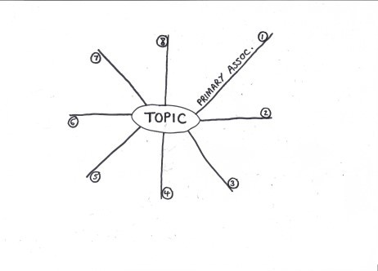
The solution here is to do a little bit of thinking before you start mapping properly. Some people find it simplest to just list some linear points to get ideas down, but others, especially if they are looking for connections and new ideas, use a radial proto-map. The process for doing this is illustrated as TASK 9.
STEP 1 – Start with a central topic and eight or so short branches connected to it. Think of the topic and then capture your eight (or so) primary associations to it along the eight branches. Remember to write along the lines, as this will save space for later.

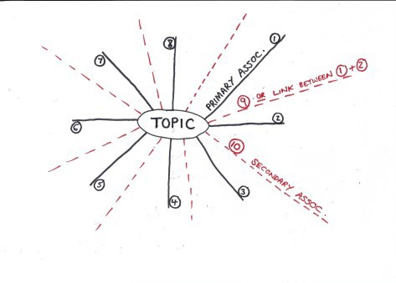
STEP 2 – Add in a second layer of branches, between the primary associations and then use these to capture your secondary associations. Your secondary associations are either the ideas that over-spilled from the primary association phase (i.e. ideas 9, 10, 11 etc) or the ideas that link two adjacent primary associations. For instance, if two primary associations are ‘Hat’ and ‘Scarf’, the secondary
association could be ‘Cold’ or ‘Clothing’ or ‘Knitting’ or ‘Striped’ etc. etc.

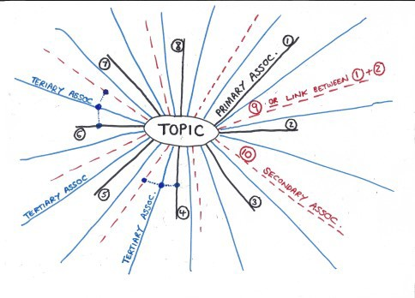
STEP 3– Repeat this process with a layer of tertiary associations. These either serve to link any two given existing branches, or simply act to capture any remaining ideas or thoughts you may have on the topic.

STEP 4– Study your proto-map and look for the thematic groups and linked ideas. These may be on opposing sides of your diagram, but may be closely situated.
Imagine that you were going to convert your proto-map into a book. What ideas would go together in any given chapter?

Use colours and icons to group them. Assign labels and titles to these groups of ideas.
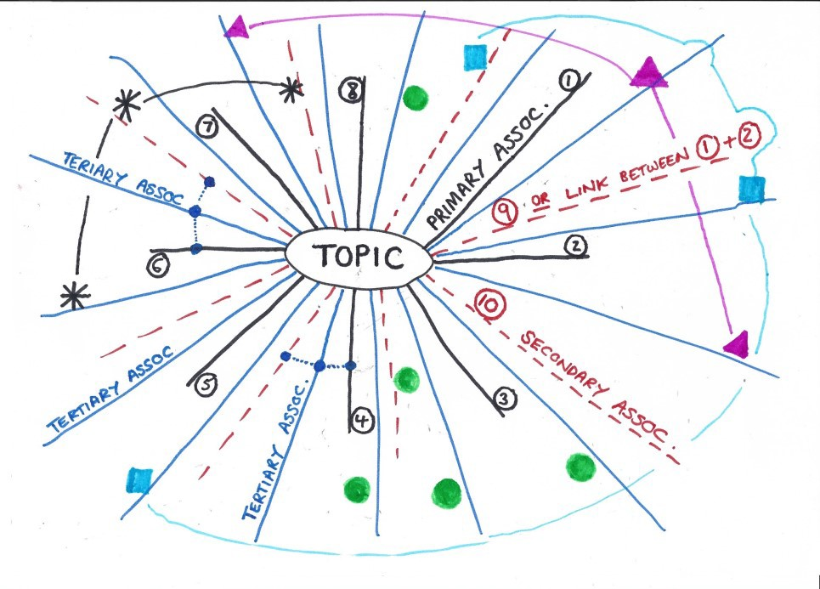

STEP 5 – Examine the groups and thematically linked associations and then consider how you would use this grouped information in prioritized form in a more conventional concept map or MindMap.

Putting It All Together

So, we’ve examined the core principles of mapping.

- Information is prioritized
- Connections are shown
- Ideas connect in a natural form
- Colour, size and icons serve to highlight and build creativity and engagement
- Macro-structures are illustrated
- Metaphysical constructs and physical examples interlink

The final step is to get on and map.
Task 10 – Get on and Map!
Clear your desk. Get a large sheet of paper. Capture your ideas in a proto-map or list. Clarify your initial structure upon which scaffold you’ll build and give it a go. Map your research question or topic or chapter that you’re about to write. Give yourself a decent 20-30 minutes to do it.

Don’t be bound by any of the so-called rules of mapping. Create something that works for you.
When you’ve ‘completed’ your map examine it and reflect on its effectiveness. Ask yourself Where are the gaps?
Where were you unclear as to the structure and form of your work? What do you need to do to your creation to make it more useful for you? Where are the links and new ideas?
How could this build over time?

Mapping and Graphic Organization is not a work of ART. It’s there, in this circumstance, to help facilitate a PROCESS.

Taking It Further

If the graphical bug bites you, there is a world of possibility out there. But do think first about what you want to diagrammatize or map and why. Revisit the PURPOSE of your engagement. What are you trying to DO with your map?
You may find that the following tools all offer value. A quick search online for the following keywords will provide ample how to films and guides:

- Fishbone (Ichikawa) Diagrams – As a problem solving tool
- Timelines – as framing devices for longituidal situations
- Word Clouds – to highlight interview responses
- Flow Charts – to illustrate processes
- Cluster Templates and Bubble Charts - To show quantities of qualitative responses
- Mandalas and Targets – to show prioritization and core functions
- Business Model Matrices – to illustrate stakeholder mapping
- ForceField Diagrams – As change-management facilitators

Further Readings

On top of the few references used in this short guide, you may want to consider how graphics and mapping might help other elements of your professional development.
Brand, W. (2017) Visual Thinking: Empowering People & Organisations through Visual Collaboration: Empowering People and Organisations through Visual Collaboration Bis Publishing

Osterwalder, A. and Pigneur, Y. (2010) Business Model Generation - A Handbook for Visionaries, Game Changers, and Challengers John Wiley and Sons

Roam, D. (2013) The Back of the Napkin – Solving Problems and Selling Ideas with Pictures
Marshall Cavendish International

Rohde, M. (2013) The Sketchnote Handbook - Pearson

Shaw, G. (2015) The Art of Business Communication - Pearson
Sibbet, D. (2013) Visual Leaders – New Tools for Visioning, Management and Organization Change John Wiley and Sons

Mapping as a Tool for Qualitative Research
If your research is qualitative, you may want to investigate mapping as a research data capture tool in its own right. The following references offer insight and examples of how this could be done:
Burgess-Allen, J. and Owen-Smith, V. (2010) Using mind mapping techniques for rapid qualitative data analysis in public participation processes Health Expectations 2010, 13, 4.
Miles, M.B. and Huberman, A.M. (Current Edition 2019) Qualitative Data Analysis: A Methods Sourcebook Sage

Meier, P.S. (2007) Mind-mapping - a tool for eliciting and representing knowledge held by diverse informants Social Research Update (2007)

Reason, M. (2010) Mind maps, presentational knowledge and the dissemination of qualitative research (ESRC National Centre for Research Methods – Working Paper http://eprints.ncrm.ac.uk/1577/)

Tattersall, C. et al (2007) Mind mapping as a tool in qualitative research. Nursing Times Vol: 103, Issue: 26, page No: 32-33

Wheeldon, J. and Faubert, J. (2009) Framing Experience: Concept Maps, Mind Maps, and Data Collection in Qualitative Research International Journal of Qualitative Methods 2009, 8(3)

This resource was created by Steve Hutchinson. Steve runs Hutchinson Training and Development LTD who provide a wide range of training, coaching and consulting opportunities

