Presenting Online –

Best Practice for ‘Live’ and ‘Virtual’ Presenting
Online Resource
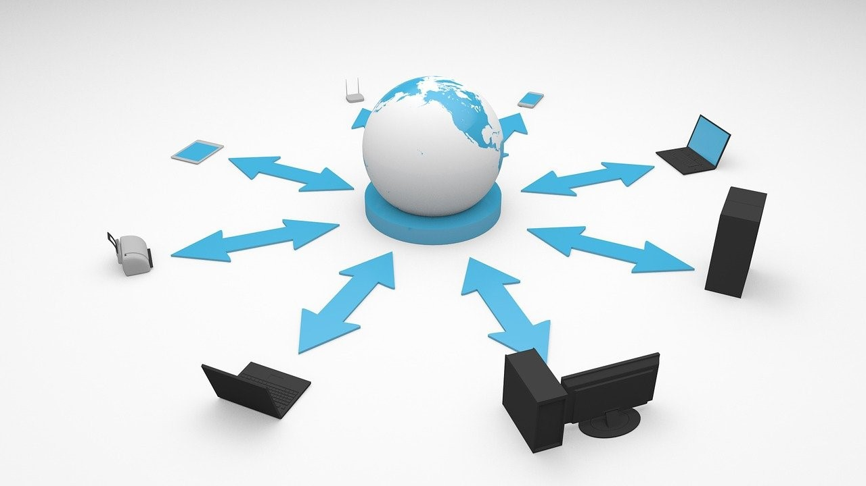

Pandemic lockdown and distancing measures meant the cancellation of face-to-face conferences, seminars and meetings. Many of these events, in some form, are now fully online and are asking researchers to present their talks virtually. This situation represents a challenge, but also an opportunity. It means that we can present our work anywhere in the world. It means we can attend more conferences without travel costs. It makes it easy for people to record our presentation and watch it at a time that fits their schedule, and thus hugely increases our potential audience and impacts.

However, in order to present well, we need to consider a number of elements that will help us to master ourselves and our nerves, use the technology to best effect, tell an engaging story aimed at the right level, engage with the audience to get our messages across in the most valuable way. This interactive guide – produced specifically for the University of Edinburgh, will help you to do all of these things.
We’ll deal with SIX areas – all of which are essential elements of being able to present your work well.

CONTENTS

Section 1 - Know Your Purpose – adding value by presenting | Page 3
Section 2 - Know Your Self – being authentic and showing confidence. | Page 5
Section 3 - Know Your Story – getting an engaging message across | Page 11
Section 4 - Know Your Style – using the right techniques | Page 14
Section 5 - Know Your Audience – getting engagement and level right | Page 21
Section 6 - Know Your Technology – using your toolkit in the best way | Page 24

Note:

Throughout this document there are a number of questions where you’ll need to think, reflect and record your thoughts and practices. To save space, we’ve not provided boxes for you to fill in, but you will find it invaluable to record your answers and insights in whatever way you prefer.

Section 1
Know Your Purpose - Adding Value by Presenting
“The single biggest problem with communication is the illusion that it has occurred.”
George Bernard Shaw – Playwright (1856-1950)
Since online became the default presentation format, a question that researchers continually ask is “how do I make my online presentations engaging to an
audience?”. My response is simple and predictable - “what did you do to make your live presentations engaging?”.
Ask Yourself

What devices would I actually use to engage and connect with a live audience?

The vast majority of these tools and techniques (eye contact and on-stage movement being exceptions) will translate to an online audience.
Of course, the problem that we have now is that people can turn off their camera and microphone and we’re no longer certain that they are even present. Either that or we must pre-record our talk with no audience at all.

So, next you must consider the notion of why you are presenting in the first place and how you are adding value or content that couldn’t be conveyed through a PDF alone? Or, to put it another way, why not simply send delegates a set of notes?

Ask Yourself

How am I adding value to an audience by presenting this work? How could they benefit from what I am sharing with them?
If you understand the value that we are adding (and this is not the same as simply telling them your research findings) then you will naturally tell a more engaging story and emphasise the correct elements of your work that engage an audience.
Top Tip

For any given section of a talk think about the verb that indicates the purpose of your talk. Such a verb might be ‘engage’, ‘entertain’, ‘amuse’, ‘reveal’ or one of many others. How would your tonality, gestures and language reflect this verb?

NB. if your purpose verb is no more than ‘tell’ or ‘inform’, then save yourself the effort and send people a PDF.
Essentially, we must understand that though research is essentially objective, a good presentation is a deeply subjective entity. To that end, think about the
presentations that you’ve seen (live or online) and think about how you felt while watching and listening.
Ask Yourself

Of the presentations and talks that you observe, how do you feel while watching and listening?
What differentiates the engaging talks from the not so good in terms of the devices that the presenter uses?

Do you feel connected to their message and story? Where and how?
What specific devices is the presenter using to connect with the audience? (Focus on the things the presenter ‘does’ – not the way that they ‘be’. Noting that a
presenter is ‘charismatic’ might be true, but is not practically helpful for you.)
When you’ve done this, try to group their connective devices into:
Verbal – the inclusive words that they use
(e.g. “I’d like you to consider a problem that affects everyone in our field.”)
Vocal – the connective way that they use their voice
(e.g. stressing key words, emphasising valuable points, conscious speeding and slowing for a connective effect)
Visual – what you saw in their slides, their digital/real body language and their interaction with their camera.

We’ll return to these three elements later in this guide; but note that the primary differentiator between a good presenter and a poor presenter is the degree to which they add value by presenting by CONNECTING. Audiences want to be involved in an engaging story. Research can be an isolating experience regardless of pandemic-related distancing, and a presenter that is able to actually connect with their

audience in a meaningful way and make them feel like they should care about the subject will always be perceived as being better in the role.

Section 2

Know Your Self – Authenticity and Confidence
“To be yourself in a world that is constantly trying to make you something else is the greatest accomplishment.”
Ralph Waldo Emerson – Writer and Lecturer (1803-1882)

As we’ve already learned in section 1 – presentations are a deeply subjective entity. An audience needs us to CONNECT, but they also need to see that the presenter is CONFIDENT in their knowledge and skills and shows COMMITMENT to their message.
To this end, effective presenters must first be able to do two things:

- Present authentically and show the audience the best version of themselves
appropriate to the context of the presentation
- Conquer their presenting nerves and show that they are confident.

Authenticity – Be Yourself (within reason)
If you ask a group of people the question ‘what makes a good presenter?’ someone will inevitably answer ‘good presenters are funny”. This may, on occasion, be true – but as a general rule it has two fatal flaws. Firstly, listening to someone who isn’t funny try to be funny is excruciating. Secondly, there are many contexts where humour is deeply inappropriate.
So, rather then apply a general maxim, start by thinking of your natural character and motivations.
Ask Yourself
How would my friends and family describe me when I’m at my best? Curious? Passionate? Energetic? Driven? Relaxed?

Then consider presenting from this authentic position.

If you’re naturally curious then you know how to make you body, eyes, tone and language curious. It’s natural for you. Similarly, if you’re energetic then you know

how to get your gestures and intonation right to show the audience authentic energy. If this notion is a little abstract for you then consider your research motivation.

Ask Yourself
Why is this topic so important to me? What do I love about my research? Why ultimately does this matter?
Ensure however, that you marry this authenticity and motivation with a degree of contextual appropriateness. Every presentation is subtly different in what is contextually appropriate. Pay attention to what is appropriate and try to operate in the overlap between your natural style and what is deemed to be appropriate (as per below).
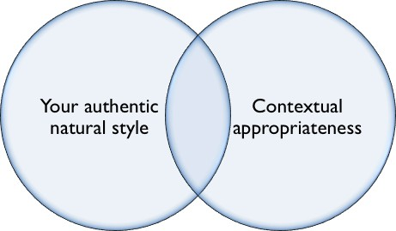
Top Tip

Think very hard about how you want to be seen by the audience. Don’t just copy what everyone else does – even if they are big professors (many of whom are barely adequate presenters anyway…). Be yourself, show yourself and show them that the talk matters to you.

Of course, much of this comes through confidence. The more confident you are in your reputation and standing the more able you are to be yourself in front of an (online) room full of strangers.

Confidence – Beat the Nerves

Confidence and nerves are, for many, the major barrier that stops them presenting their work well. They feel nervous and so create crutches for themselves (e.g. lots of text on their slides to read when they forget their words), which actually stops them presenting well. They see a talk as a battle with the audience, and as something just

to get through – both of which are at odds with the core presentation tenets of showing that it matters and sharing your interest with the audience.
Ask Yourself
When you are confident, how do you sit, stand, look, act and talk? What posture and gestures indicate (authentically) that you are confident?
Presenters, whether online or live, need to show the audience that they are confident; and in doing so, show that the audience can have confidence in the message that they are hearing.
Ask Yourself

What preparation (of both the presentation content, and of you personally) do you need to do so that you can behave in a confident manner?

What specifically is getting in the way of you behaving in a confident manner?
By addressing the specific elements that cause you presentation nervousness you can start to prepare for these eventualities in a productive way. For instance, if they really examine their beliefs, many people are more nervous about the questions at the end of a talk (as they cant control them) than they are about the actual presentation.

As you are preparing for your talk create a list of the presentation stumbling blocks that cause you to be nervous. Within this list identify the things that you can control, influence and those elements that are outside of your control or influence. For example:

Potential  Stumbling Block | Classification | Action
e.g. You over-run | CONTROL | You can CONTROL this with practice and by managing your audience’s expectations so  they don’t interrupt until the signposted question section at the end.
e.g. Forgetting what you want to say | INFLUENCE | You can INFLUENCE this by a) practice and b) having post-it note prompts stuck around your computer screen to remind you of key  elements.
e.g. An audience knows more than you | Outside Your Control / Influence | There’s nothing you can do here, so ACKNOWLEDGE and EMBRACE it, and  remember the value that you add. Build in a line such as “I feel very honoured to be  talking with a group where there are so many

experts. Though I’m relatively new to the field, I’d like to ask you some questions and perhaps make you all think from a new
angle.”
e.g. Some asks | Outside Your | Again, there’s nothing you can do here so
you a question | Control / | ACKNOWLEDGE and EMBRACE the question.
you hadn’t | Influence | “That’s a really useful question. I don’t know
thought of |  | – but I’ll certainly look into that approach,
 |  | thank you.”

In essence, control the controllables, influence those things that can be influenced and acknowledge and embrace anything else. The audience doesn’t expect omnipotence or omniscience. It expects someone to do their best.
We’ll examine being the master of your technology, message and story later on in this guide.
As you start to take ownership of the problematic areas of your talk you’ll naturally start to act and speak more confidently. However, it is possible to take short-cuts to a confident persona and presenting style.
Top Tip

Sit in front of a mirror or your webcam as if ready to present and then locate your sternum; the bone plate in the centre of your chest (X below). Raise it by an inch or two. Your head will lift, your shoulders will pop back and you’ll instantly look like the confident version on you.
Secondly, try to fill the ‘zoom triangle’. Take a line from the base corners of your screen to the top centre or webcam (Y below). Aim to fill this triangle, you may need to experiment a little. (If it’s a really important talk, I put my laptop on top of my filing cabinet and I stand up.)

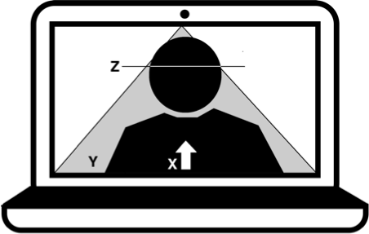

Thirdly, lift your camera so that your eye line is about the same as your webcam and the audience sees you looking straight at the screen. Your eye line (Z above) should be about 2/3 of the way up the screen.

When it comes to confidence, it’s important to understand that audience generally remembers the first and last parts of the talk more than they remember the rest. This is sometimes called the laws of Primacy and Recency.
Most presenters tend seemingly to ignore these laws and both ‘warm up’ on stage (i.e. their introduction is weak though their content is perfectly acceptably) and overrun and rush the ending (thus spoiling an acceptable talk).
It is thus necessary to build your confidence so that you start strongly. There are myriad ways of doing this, and no one-size-fits-all technique. Here are some confidence-building strategies that people find useful.

- Know your stuff - really know it. If you need notes – stick up post it’s on the side of your screen to remind you of key points (as below).
- Know your transitions. How are you going to seamlessly move from point to point? If possible print out your slides as a multi-slide ‘handout’ view. This lets you see the what’s coming next even if online platform only lets you show one slide (as below).

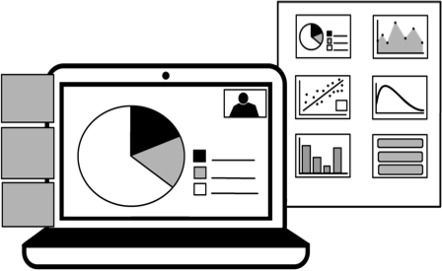

- Practice, practice, practice. But remember practice doesn’t make perfect, it makes permanent. So, practice in as real way as possible. With a supportive test audience, out-loud and without ‘start-agains’ if you go wrong. Practice extricating yourself from mistakes – as that’s what you’ll have to do in reality.

- Make sure you really understand how your technology works and what things do. If you’re using a new online platform, arrange with the organisers to have a practice run before the audience arrives.
- Arrive early. Get yourself set right.

- Don’t over-rely on technology. When the web link doesn’t work or the animation doesn’t play, what are you going to do? Keep things simple and have contingency plans.

- Many people can find presenting difficult, but the question and answer section (if the questions are ‘easy’) presents them little challenge. So, write your talk around questions (engage the audience by making them think) and pretend the audience has asked you those questions.
- Don’t think of it as presenting. Think of it as sharing an interesting story about your work with one person at a time. Everyone can do that!
Ultimately when you can’t see a huge live audience, an online presentation can be far more intimate, less stressful and more engaging.
Finally, the secret of building presentation confidence is a combination of a) controlling the controllables, b) practice and c) receiving supportively-critical feedback from colleagues and good presenters.

Build your confidence so that you can:
- Simplify your material so it’s actually aimed at the audience (not your supervisor…)
- Cut your quantity of material (inexperienced and nervous presenters always use too much)
- Use simpler slides that don’t require you to read every word
- Be flexible enough to involve and include the audience
- Embrace ‘difficult’ questions and include these in your talk, even if you don’t answer them (“I know that some of you are wondering about factor X, well, unfortunately…”))

•

Section 3
Know Your Story – Getting an Engaging Message Across
“If you can't explain it simply, you don't understand it well enough.”
Albert Einstein – Theoretical Physicist (1879 – 1955)

Whether online or live, the key element in writing and delivering an engaging talk is to have an engaging story with a clear message. Many presenters dilute their key message with tangential content or details that the audience wont remember or can’t place within the story.
As we’ve learned so far in this guide, the best presenters are the ones who can authentically frame their story and share their passion for the topic. Craft your story by first considering these five fundamental questions.
Ask Yourself
- Harness Your Passion
What is it about your subject that hooked you and continues to hook you?

- Get My Attention
What fact or element of your work (even the context for it) is going to make the audience wake up and pay attention? (For instance: “One in every three people in the UK will suffer from X during their lifetime.” or “The coronation of Queen X cost the country, in today’s money, £X billion.” etc).
- Focal Problem
In one sentence, what is your research area or thesis question? Can you state it as a problem to solve which will make an audience curious?
- Take Home Message
What is the one sentence you want your audience to remember? (It’s difficult to reduce three years work to a twenty minute talk, but comparatively easier to start with one sentence and build upwards.
- The Big Fat ‘SO WHAT?’
What is the value that your research will add? Why is your work necessary? Why is it necessary NOW? (Make the audience care…)

It’s unlikely that you’ll ever write a talk where you deal with these question in this order, but your introduction should probably deal with most of them in some form or another!

Linked to this, it is vital that take your audience on a narrative journey where the content of your work is clearly and contextually framed.
Think about your talk like an hourglass. The top is broad (context), the centre is narrow (focused content) and the bottom is broad. Your story should open and close with context and, in effect, close the narrative loop for the audience (as per below).
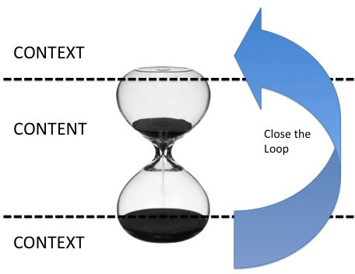
By starting with a broader context you’re more likely to engage an audience who will understand and be effected by the context even if they don’t understand your methodology and content. Ensure that the audience has a clear sense of:

WHY? – the context and motivation for your work
HOW? – your methodology and approach and your personal take on this. (You wouldn’t publish that you we’re ‘surprised how difficult this research process was’, but this secret makes your talk vastly more engaging.)
WHAT? – what you found and what it means
SO WHAT? – what are the implications for the audience / research / humanity NOW WHAT? – what’s the next step? (Make the audience think about future potential, and they’re more likely to engage and ask you interesting questions.

Combine these questions into a smooth story that funnels in and out of your hourglass – as below.

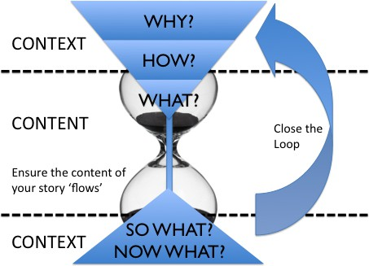

Obviously, every audience is different and you’ll need to mould the hourglass to fit their need and level. (For instance, a specialist audience might need a stretched hourglass with less context and more content. A very generalist or non-specialist audience will need a compressed hourglass with proportionally far more context. Nonetheless it is vital that your story flows in a meaningful way.
Top Tip
Draw the structure of your talk like a road map with content elements as ‘towns’ along the way. Work out exactly how you’re going to get from town to town smoothly. Signpost this journey in your introduction (i.e. “Today, we’re going to
focus on three key questions. Firstly…” etc) and then plan your transitions carefully (i.e. “So, now we’ve examined our first question, let’s turn our attention to the second…”)

When crafting your story (which, by the way, is best done well away from your computer – and the copy and paste temptations of PowerPoint) you need to ensure that you don’t overload your audience with too much content. It’s better to present three things well than five things badly, and (especially online where you need to slow down and repeat regularly) the audience simply can’t handle as much as you can – after all, you’re the expert on your topic, not them. Judicious editing is vital.

Top Tip
When you are preparing your talk, write down in note form everything that you think you need to say. Then engage in an editing process sometimes referred to as traffic-lighting. Take three coloured pens (red, amber, green) and mark your notes equally with three colours.
Green – absolutely essential. This must be included.
Amber – not essential. Leave it in reserve for if the audience are expert/capable/receptive.
Red – cut it. Cut it now.
At the end of this editing process you should have deleted at least one third of what you though you should say.

Of course, there are other ways to tell a story, but addressing the fundamental questions, and traffic-lighting the hour-glass will give you a firm foundation for most research talks. Furthermore, ensuring the audience ‘gets’ the contextual big-picture, you’re much more likely to engage them.
•

Section 4
Know Your Style – Using the Right Techniques
“It is not the voice that commands the story. It is the ear.”
Italo Calvino (Writer and Journalist 1923-1885)

As we’ve already examined in this guide, are able to show authentic CONFIDENCE, demonstrate their motivation and COMMITMENT and build engaging CONNECTIONS with their audience. In this section we’ll address some specific techniques of online presenting to achieve these aims. There are of course, many more that we won’t have the space for! We’ll broadly focus on:
- Verbal – your inclusive language, script and words.
- Vocals – the connective way that you can use your voice, and what the audience hears
- Visuals – what you show the audience, your digital/real body language and your interaction with the camera, and PowerPoint.
And we’ll present these elements as a series of checked questions to help you evaluate your own performance.

Of course, as in section one of this guide, everything that follows should be tempered with a clear understanding what your OBJECTIVE is and what purpose VERB is governing any given section of your talk.

Verbals - What You Say
Do you have a clear and purposeful introduction? | Y/N
Does your intro get the attention of an audience – and have you tested this  on an audience that isn’t you or your supervisor? | Y/N
Have you managed the audience’s expectations and behaviours? | Y/N
Top Tip
When presenting online it’s vital that you:

- let the audience know what to expect. (“There are many elements to this subject, but today we’re going to focus only on three.”)
- let the audience know how you want them to behave. You need to show confidence and lead their behaviour. (“It’d really help me if you switched your cameras off and saved questions to the end.”)

Are you clear about the benefit of your message to the audience? | Y/N
Do you avoid jargon wherever possible? | Y/N
Where jargon is unavoidable, do you explain it properly? | Y/N
Do you signpost the structure of your talk? | Y/N
Is your language ‘inclusive’ of the audience? | Y/N

Top Tip
Listen to speech radio. Radio Four, LBC etc. Notice how inclusive the language is. (“Today, we’ll be examining the issue of…” etc) As a listener you feel involved and drawn into the story, topic or debate. Inclusive language is a powerful tool for the online presenter. Think of your presentation, not as ‘presenting to’ but ‘talking with’ the audience.

Does your story clearly flow from point to point? | Y/N
Are you accidentally modifying your message?¹ | Y/N
Have you written your talk around questions, or devices that make an  audience think and intellectually engage? | Y/N

1 There is a massive difference to an audience between:
“This has the potential to be valuable” and “Er… this might be quite valuable.” The first is a conscious academic indication of balanced significance; the second is an accidental undermining.

Have you constructed your talk around an ‘hourglass’ (Why?, How?, What?,  So What?, Now What?) | Y/N

Top Tip
Practice talking to ‘dead air’. Learn not to rely on audience nods, smiles, reactions and involvement. Ironically, the better ‘live’ presenter you are, the harder at first it is to talk with interaction. However, it’s a skill that can be learned with minimal practice.

In terms of time-keeping, have you edited your work sufficiently so that you  under-run slightly and leave sufficient time for questions? | Y/N
Do you have an alternative way of explaining any given concept in case an audience doesn’t get your preferred explanation device? | Y/N
Have you considered counter-positions to your argument and questions  that an audience may ask? | Y/N
Are you recapping regularly? | Y/N
Have you built in enough time for an effective summary? | Y/N
Do you have a clear and concise conclusion? | Y/N
Do you have a clear line that tells the audience that you’re finished? (e.g.  “I’d like to thank you for your engagement and I’ll happily answer your questions or take feedback now.”) | Y/N

Ultimately, the audience has logged on to listen to YOU and your take on your work.
They don’t just want a list of facts. So if something is important – lean in to your camera slightly and tell them that ‘this is vital’. To this end, presenting is actually very simple. Just keep things real.

Vocals – How You Say It
One of the great mis-reported pieces of psychological research is that communication is 55% visual, 38% tonal and only 7% words. This may be correct when it comes to the signalling of emotion or feeling², but it is not universally applicable to all forms of communication. Nonetheless, it is important to realise that our script is not all of message and the way we say specific words and sentences can significantly alter their meaning in the ears of the audience.
Top Tip
Practice repeating a single sentence using different tonal inflections and stresses. Listen to the different meanings each iteration conveys. For example:

² See the work of Albert Mehrabian

“I’m not saying that Sam stole your idea.” “I’m not saying that Sam stole your idea.” “I’m not saying that Sam stole your idea.” “I’m not saying that Sam stole your idea.”

When it comes to presenting, think about which word in each sentence or paragraph needs to be really emphasised to get your message across.

This tonal emphasis is even more important online where an audience is deprived of most hand gestures and subtle body language cues.
As before, here is a series of checked questions to help you evaluate your own performance.

Have you recorded your own voice to hear what you sound like?³ | Y/N
Have you reduced your pace? (Vital online, where people’s audio feed may  not be ideal.) | Y/N
Have you remembered to slow down especially on the larger or more  technical words?⁴ | Y/N
Have you sought feedback about your volume, diction, pace, pitch and  timbre? | Y/N
Have you, wherever possible, minimized your ‘filler words’ (er, uh, ah, um)  or replaced them with conscious pauses? | Y/N

If as an online presenter, what we seek is audience engagement, then it is important for us to leave sufficient space in our talks for them to actually engage.

Are you using sufficient pauses – especially after questions – to allow the  audience to think and process? | Y/N
Do you leave sufficient pause after each new slide or concept to allow an audience to process with what they are being asked to look at / think  about? (Essentially – minimize the amount of audience multi-tasking.) | Y/N
One of the big challenges with online presenting is the lack of audience response. You simply cannot see an audience nod, smile or agree. This lack of response has directly led to two vocal phenomena which undermine a presenter’s credibility.
- The use of the word “OK?” after every point. This undermines credibility as it signals a lack of confidence in what the speaker says, OK?...

³ An experience unilaterally regarded as ‘horrific but helpful’.
⁴ Nervous presenters, or those working in a non-native language, often speed up on the technical words, since these are the words that they fear stumbling on. This is precisely, from an audience’s perspective, the wrong thing to do.

- An upwards inflection at the end of a sentence. This makes everything sound like a question. (Some people do this anyway, which is fine, but don’t start doing it simply because your audience has their webcam disengaged.)

Visuals – What The Audience Sees
To a greater or lesser extent, the Verbal and Vocals of presenting are similar whether the talk is live or online. The area of greatest difference is in body language and, especially, eye contact.

Top Tip
Lift your webcam up to eye level, sit up straight and sit at the front of your chair so that you can’t rock back. Ensure the audience sees a professional version of you.

The trust created by the perception of eye contact is incredibly helpful in getting a message across to an audience, so it’s important to look at your webcam. It can be tempting to look at your notes or down at your keyboard – so a bright fluorescent arrow (as per the diagram below) pointing at your webcam (mine says ‘FOCUS’) can help. (Some people apparently use a photo of someone they like looking at stuck next to their webcam.)

Some people are naturally more expressive with their gestures than others. Remember than any gestures outside of the rectangle of a screen wont be seen, so if you use gestures (‘There are three [show three fingers] key things to remember…”) practice moving your hands from your elbows not from your shoulders and keep everything in the X zones (below).
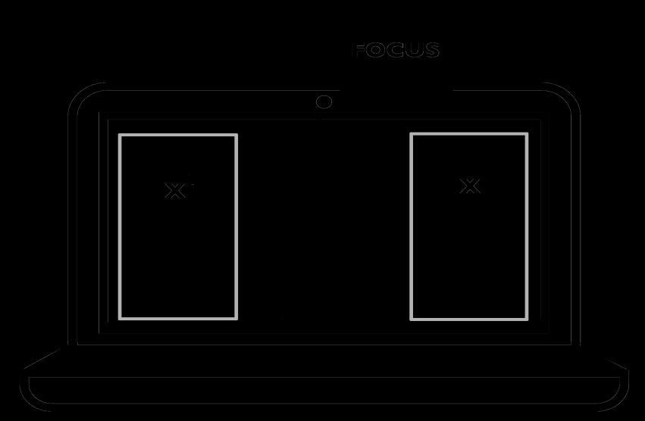
What’s important here is to ensure that the audience sees an authentic human being, who is comfortable but contextually appropriate through their screen, so practice until you are familiar with your onscreen persona.

Top Tip
Watch a variety of television presentations (e.g. News readers, politicians, business leaders, reporters) with the sound turned down. Some of their body language behaviour seems odd and inauthentic⁵ . Don’t copy these behaviours but look for where their controlled gestures help their words and augment their script.
As an online presenter you need to ensure that you are practiced enough with the online conferencing software so you know how to set it up in a way that helps and doesn’t distract you. (For instance, personally, I like to see people’s faces while I present so I can gauge reaction. Not everyone feels this way and some would find it hugely distracting. Also, some platforms and some conferences don’t allow this option. Practice until you’re comfortable in a range of situations.)

Again, here is a series of checked questions to help you get the visual aspects right.

Are you dressed in an outfit that is smart and appropriate, and that make  you feel confident? (But is also comfortable.) | Y/N
Have you minimized your visual distractions so you can focus on your  webcam? Are you sitting and acting like the confident version of yourself? | Y/N
Top Tip
You may find it useful to move back from your screen / webcam so the audience sees your head and torso, not just your face. If so, you may need to use a mouse or ‘clicker’ to move slides on. (This has the added advantage of stopping webcam shake.)

Are you sitting and acting like the confident version of yourself? | Y/N
Have you sought feedback about your gestures and eye contact? | Y/N
Have you practiced a variety of options so that you get the visual cues you  need from your audience? | Y/N
Have you practiced with no audience response at all. (Essential for pre-  recorded talks.) | Y/N

Of course, all of the above must sit within a technological environment and we’ll discuss this in Section 6 (Using Your Kit). However most of the visual (eye contact and body language) elements can be addressed with one simple question set.

Do you look engaging? Do you look pleased to be speaking with the  audience? | Y/N

⁵ Some political body language is incredible to watch. As a starting point, look for a) the ‘karate chop’ decisive gesture; b) the ‘thumb over the fist’ to apparently show assertiveness not aggression; and c) the ‘open hands and wrists revealed’ “trust me” signal. Don’t copy this nonsense.

Ultimately, if you want them to engage, you have to lead by example.

Visuals – PowerPoint, Keynote etc
The other source of visual information that your audience receives is through your slides. Whether you create these in MSPowerPoint, Prezzi, Keynote or another
package it’s important that these visual ‘aids’ actually help the audience – and allow you to present at your best.
Ask Yourself
List the ‘top’ five, worst things you hate about PowerPoint when used badly.
We all know the bad practice and the traps that poor PowerPoint users fall into⁶. Don’t be one of these people.

There are four maxims that are helpful to remember when it comes to slides.
- Keep it Simple (this gives you flexibility to expand or contract an explanation and tailor your accompanying speech to an audience)
- Keep it Graphical (SHOW but don’t WRITE)
- Keep it Visible (especially figure captions and labels)
- Don’t make the audience multi-task. Show one thing at a time.
Top Tip
Not every online presenting platform will show animation in the way you want. Broadband limitations can prohibit film and audio in presentations. It’s worth having a simple back up version or your slides as a PDF document in case of problems.

Ultimately, when it comes to your style and presenting technique it’s vital to remember that there must be alignment between the:
Verbal – What you say. Vocal – How You say it. Visual – What you show

But of course, what really matters is not what you transmit, but what the audience receives. With online presentations you’re slightly disconnected from this reception, so we’ll examine audience interaction in the next section.

⁶ Too much text, too small text, pointless animations, ludicrous colour-schemes, too many figures on one slide, illegible figures and legends… etc. We all know them.

Section 5
Know Your Audience – Engage at the Right Level
“I’ve learned that people will forget what you said, people will forget what you did, but people will never forget how you made them feel.”

Maya Angelou (1951 – 2014) Writer, Poet, Activist

A presentation that fails to account for the fact that the audience is a group of individuals with specific expertises and motivations will always be poor. Pitch at the wrong level of expertise and you baffle or patronize. Fail to account for limited concentration span and the myriad distractions available for an online audience and they’ll simply turn their camera and speakers off and go and check their email.
Top Tip
Break your content up. Ten minutes is the absolute limit without change, interaction, feedback or questions. (Personally, in a 20-minute conference talk I write the presentation around three⁷ questions of about five minutes each.
(Questions to make an audience think, three because it’s an intuitive narrative structure and five minutes per question to fall within most people’s concentration span limit.)

It’s vital that we know our audience and aim at their needs, wants, level and in a way that builds on their knowledge. This is no different in a live or online presentation.

Top Tip
If you can, obtain a delegate list. Who will be present? Do your homework on some of the audience. How does your work connect to theirs? Nothing engages any audience like a presentation being about them!

It’s also important then that we ask, intuit, observe or have requisite real-time flexibility to interpret what our audience might need.
Top Tip
If you can, ‘arrive’ early. Hang around in the virtual networking space at any conference. Find out what people know and work out links between their work and yours.

⁷ Three is a long-standing intuitive narrative device. Jokes and stories often are constructed on threes (three acts, three characters, three repeats etc) (Notice that there are lots of threes in this guide (‘Verbal, Visual, Vocal’). This is not an accident.

This might all seem like hard work, and in an ideal world your work should speak for itself, but a little effort is worth it – especially if it helps you to relax into the
presentation. If such audience scoping is impossible then you’ll have to empathise and intuit rather than ask and observe.
Ask Yourself
When you see a great talk:
What level is the speaker aiming at? (Clue: it’s better to underpitch slightly and then expand, than it is to confuse the audience.)
What connective devices do they use? (Stories, case studies, personal anecdotes, questions?)
What gives a speaker credibility from your perspective?

In this guide we’ve addressed the notion of authenticity, credibility and style (what the Greek Philosopher Aristotle (384-322 BC) referred to as ETHOS), but it’s also important to balance your talk with an appropriate blend of data, facts, figures and logic (LOGOS) and stories, values and even emotion (PATHOS). Too much or little of any one of these elements (in any type of talk) results in an imbalance that will rapidly disconnect an audience.

Get the ‘Level’ Right
With an online talk it is paramount that we aim at the right ‘level’ since we cant see the frowns of an audience when we are too technical or the eye-rolls when we are too simplistic. And, as with all talks, some of your audience may be unfamiliar with specifics of your work (and may not care…). Some of the audience might know considerably more than you.

Here are some tips to help you get the right ‘level’.

- Be honest with yourself. How much of any given talk that you hear do you fully comprehend and can you recall? (A nervous presenter will generally overload the content and level because they fear any ignorance may be exposed.)
- For an academic audience, aim at yourself before you started the your current project. You have a good grounding, but minimal technical knowledge. Certainly don’t aim it at your supervisor.

- Manage the expectations of the audience (“There are myriad possibilities, but today we’ll focus on only one…”).

- Manage any interruptions (“I know you’ll have questions, and I’ll take them at the end…”).

- Understand what is ‘normal’ jargon for your audience. If you are unsure, explain terms the first time.
- Think about who you’d like to read your work. Experts in your field will read your work anyway. You’re interested in the people at the fringes of your discipline, who might read your work. These people lack the jargon that you use every day.
- Explain your terms – especially for a mixed audience (“There’s a wide range of disciplines here, so let’s explain some terms…”).

- Can you explain complexity with commonplace (“Think of this pathway like a motorway and imagine this molecule is like a Police car…”).

Ultimately, the best presenters (live or online) use simple slides and are comfortable, flexible and are confident in their knowledge to interact with the audience and change their level to suit. Simple slides set you free to do this. Text and bullet points hold you captive.
Finally in this section, it’s worth seeking feedback with trusted colleague to find out what worked and what didn’t. Ask them precise questions (“Where did you lose the flow of my argument?”) and listen to what they tell you. You may also want to record your online performance for learning, reflection and review.

Section 6
Know Your Technology – Using Your Toolkit in the Best Way
“Man must shape his tools lest they shape him.”
Arthur Miller - Playwright (1915-2005)

As online presenters it’s important that we use whatever technology we have to the best effect. You don’t need an expensive computer, multiple screens, a professional editing suite, or a TV studio to give great talks but it is important to use your tools well.

In this section we’ll examine the technological aspects of presenting online, and present some ideas, tricks, tips and questions to help you look and sound your best. As always, you should set up a fake conference call and practice and rehearse with a colleague so they can give you feedback about elements such as lighting and sound. In doing so, you’ll ensure also that you really know how to use your technology to best effect.
Top Tip
It’s not always possible, but ensure your Wi-Fi access is as good as it can be. Situate yourself near the router and check your laptop is fully charged and plugged in.

Essential Kit
Of course, it’s possible to be a good online presenter with just a laptop, but you may find that a few easy to locate or cheap additions help your performance considerably. Many of these are outlined in the diagram below.
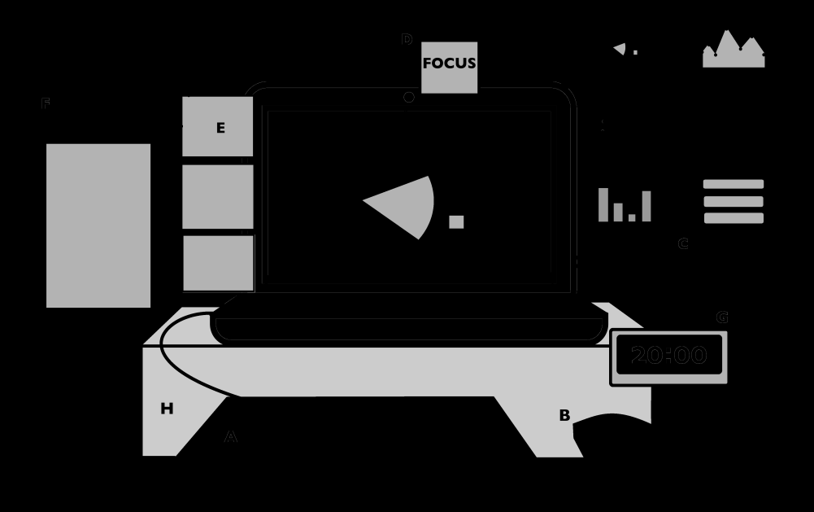

- Separate keyboard – allows slide changes and chat-typing without wobbling the computer. Allows presenter to sit back from webcam.
- Separate mouse – allows presenter to sit back from keyboard.
- Printout of slides (handout view) – shows presenter transitions and overview. Can be annotated.
- Webcam focus prompter.
- Post-its with key message or important data prompts.
- Diffused light source (or ring-light) to ensure face is well lit. Not too bright, and be careful if you wear spectacles.
- Timer / Clock – regardless of what you see on-screen, it’s useful to help manage your pace.
- Raised platform or stack of books to lift your laptop so the webcam is at eye level. (Or a separate webcam at eye level.)

Lighting

- It’s important to light your space well. Don’t sit with a window behind you and try not to mix natural and artificial light.
- You may find that investing in a ring-light that fits around your webcam is worth it, but this doesn’t work well for glasses wearers. (If you wear spectacles, use diffused light or light from both sides.)

Sound

- Ensure that your speakers and microphone work well. (You may need to invest in or borrow a headset microphone. The one that came free with your phone probably works just fine.)

- Eliminate as many sound distractions as you can. Ensure you’re not presenting in an echo-prone room (your kitchen, or your work lab).

Professionalism
- There are lots of funky filters and backgrounds that you can use. The gaps between the real and the fake tend to be distracting. A plain wall or bookcase is infinitely better. If you can’t find enough blank wall or really value your own privacy, set your background filter to ‘blurred’.
- Dress smartly (as discussed already) and try to limit your attire to simple, plain blocks of colour.
- Lift your camera. Ensure that the camera is at or above your eye-line.

Top Tip
Learn the keyboard shortcuts in PowerPoint. Knowing these means you don’t need to wave your pointer around constantly. If your settings allow the audience to see your on-screen pointer it can be hugely distracting if you constantly move it.
- Be explicit (at first) about what you’re doing. (e.g. “I’m just putting my first slide. Can you see it?”) This simple check ensures that they can see what you think they can.

Recording Your Talk
If you’re in any doubt about your broadband, you may want to ask about the possibility of recording your presentation and ‘going live’ just for the questions at the end. If this is the option that you take, all the advice in this guide holds true – and ensure that you don’t eschew engagement devices such as questions to the ‘audience’.
Remember to linguistically involve the audience (“It’s great to be able to share my research with you today.”) and make sure your pace doesn’t increase.

Finally, for pre-records it’s vital that you find a way of creating a controlled nervousness in yourself (the audience normally does this for you) that will give your talk an energy and vigour.

Conclusion
It’s a strange and convenient quirk of life that people who can articulate ideas well are seen as being clever (and employable…) – sometimes when this is untrue! Of course, you ARE clever and engaged in work of real value – so it’s worth really putting the effort into writing, practicing and delivering a really great talk.
You can do this, as we’ve explored together in this guide by:

- Knowing Your Purpose – adding value by presenting.
- Knowing Your Self – being authentic and showing confidence.
- Knowing Your Story – getting an engaging message across
- Knowing Your Style – using the right techniques
- Knowing Your Audience – engaging at the right level right
- Knowing Your Technology – using your toolkit in the best way

Finally, enjoy presenting. There’s no point in our work at all if we’re not able to share it; and when you present you’re sharing groundbreaking ideas and data with the bright people who like learning. Presenting, online or live, is a real privilege.
Embrace it!
•
Dr. Steve Hutchinson
Produced for University of Edinburgh - 2021

