3MT® —Designing Effective Slides for the Competition
A Study Guide



Allan Gaw





TABLE OF CONTENTS
Introduction 3
What are 3MT® slides for? 6
‘S’ is for Style 8
‘W’ is for Words 14
‘I’ is for Images 16
‘P’ is for Palette 26
‘E’ is for Extras 30
Examples of winning slides 34
Conclusions 40
Further Reading & Resources 41
About the Author 43
Acknowledgements 43

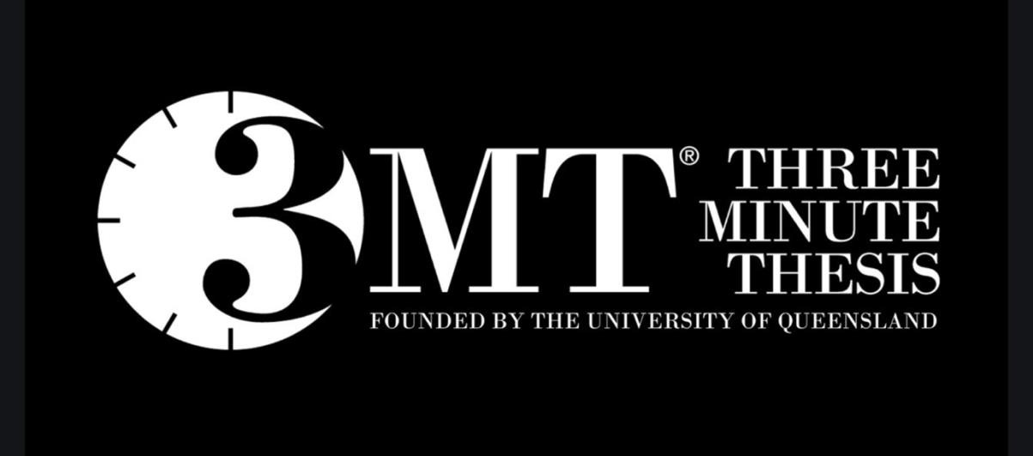

INTRODUCTION

The Three Minute Thesis (3MT®) is an annual competition that requires doctoral researchers to present a compelling, spoken presentation on their research topic and its significance in just three minutes and using a maximum of one slide.
It is an academic competition developed by the University of Queensland in Australia, but the concept has since spread across Australia and New Zealand and has gone global with over nine hundred institutions from more than 80 countries now participating.
The University of Edinburgh has run a 3MT® competition every year since 2013 and participation is widely encouraged. It allows contestants to hone and develop their academic presentation skills, and most former participants cite the value of meeting other researchers from very different fields and even institutions as one of the best aspects of the event.
There is much that can be said about the design of a short, effective, oral presentation to a non-specialist audience, which is what the 3MT® requires, but in this study guide we are going to look in detail at the issues surrounding the design and use of that single slide.
When it comes to the competition rules that specifically relate to use of the slide, these are worth noting in detail.

First, they state that a single PowerPoint slide is permitted, but they do not say it is compulsory. A number of entrants and even some UK finalists have delivered their presentation with no slide backup. However, as we will see later, no one has won the UK competition in recent years without including a slide.

Importantly, the rules say that the slide must be static, with no slide transitions, animations or ‘movement’ of any description and that includes the use of audio or video files. The single slide is also to be presented from the beginning of the talk so there is no opportunity for a sudden dramatic reveal at the end.

This poses some interesting challenges when it comes to choosing what to show. Understandably, contestants spend a lot of time developing their oral presentation, ensuring that it is clear and engaging, but some do this to the detriment of the visual component which unfortunately for some is seen as an afterthought. It can be argued that the single slide you present will be the least important aspect of your talk, compared to your voice, your stance, your enthusiasm and of course your content. But that can be a mistake. Probably no one has ever won the competition just because they had a killer slide, but I am certain some have lost it because of a very poor one.

Remember, you only have three minutes to impress your judges and if you start by showing them a complex, difficult slide that they have to strain to read, you may have distracted them from what you are saying and maybe even lost them altogether. In a much longer presentation, you can get away with a lot, but if you only have 180 seconds to make an impression, you have to make every one of them count. You need your audience’s undivided attention from the moment you open your mouth.

In this Study Guide, I want to spend some time thinking about what the single slide you will use at the competition is for. Then, I want to say some general things about good slide design—some are obvious, some not so much. And finally, I want to look at examples of slides used by winners to see if we can glean any further information to help us.



WHAT ARE 3MT® SLIDES FOR?
Most speakers will use visual aids to enhance, illustrate and signpost their presentations, and the most commonly used visual aid is the slide.

University lectures, conference presentations, business pitches, classroom talks—these are just some of the many examples of presentations that may be supported by a slide show. Speakers use slides for different purposes. For some presenters, their slides are their script. The slides will be heavily laden with text, and they will be read word for word from the lectern. For others, their slides will be a series of prompts and cues, helping them through the presentation with a series of gentle reminders. And, for other presenters, their slides will not be for them at all, but for their audience. The latter group of presenters are using their slides most appropriately. Slides should be used as visual aids for the audience, not necessarily for the speaker. However, to be a visual aid the slide must be visual and must be helpful. To be ‘visual’ it must be clear, easily comprehended and, well, quite simply visible. To be an ‘aid’ it must help the audience to understand what the speaker is saying. The latter may be achieved by using slides to illustrate a point, to clarify a complexity or to carry forward an argument.

When thinking about the slides used in the 3MT® Competition, there are some further things we must consider.

If you can only show a single slide, what are you trying to say with it? Broadly there are two approaches adopted by contestants. First, there are those who try to tell the story of their work on that one slide. Given that there is often a very great deal that you could say, this can be a problem. Every doctoral student could talk for some time just about the background to their topic and their research question. Depending on what stage they are at with their work, they may have just as much to say about their findings and their conclusions. Added to that, there is the complexity that in the 3MT® Competition you are having to explain your work to a non-specialist audience who will not necessarily be familiar with the vocabulary you use, or the concepts you take for granted. Obviously, there is no possibility of including all this in a single slide, which means if you do go down this route, you have to make some hard choices. Ultimately, it will be about deciding what is the most important part of the story you need to tell and how you can tell it as simply as possible.
The other, alternative approach, used by many contestants, is to accept that no single slide can cover the detail they wish to present, so they use the slide as a backdrop to their talk rather than a slide containing the information they want to impart. Such backdrops might be a single striking image that evokes the topic or the issue that you are discussing. Similarly, it might be a single visual example that puts everything into context or a visual analogy that will help your non-specialist audience understand what you are talking about and perhaps even why you are talking about it.

Later we will see examples of both these strategies in action, but first it is worth saying some general things about good slide design that apply whether you are showing a deck of fifty slides or just one.

The principles of good slide design are not complicated and simplicity is the overriding consideration. Despite this, most presenters in academia are either not aware of these prinicples, or do not feel they apply to them. I suspect it is the latter. The application of these principles generally results in simpler, cleaner, less cluttered slides, but many presenters apparently see simplicity as something undesirable, preferring to present more rather than less, in case their talks will be deemed simplistic and therefore insubstantial. In this respect the approach of the renowned German/American architect Ludwig Mies van der Rohe is appropriate— ‘Less is more,’ he counselled, and he was right.

Some think that simplicity will betray them, leading the chairperson, the other speakers and the audience to conclude that their work itself is simple, and therefore lightweight, just because they are explaining it in a simple fashion. In fact, simplicity is appreciated by audiences the world over. Indeed, it was Leonardo da Vinci who said: ‘Simplicity is the ultimate sophistication’ although admittedly he did say it backwards and written in code. If you prefer your inspiration a little less esoteric and a little more up to date, Coco Chanel said, ‘Simplicity is the keynote of all true elegance. Or, in other words, when it comes to slides, think: little black dress.

Clear, concise messages unadorned by the complexity that is possible through modern technologies, delivered in a simple unassuming style will usually win the day. As you gain experience and confidence, you will develop your own style, but this should never be at the expense of the simplicity with which you began. Great presenters have style, but they also have clarity and above all, simplicity. Never mistake simplicity for lack of content or depth.
Thus, keeping it simple is a highly desirable approach, and one especially that the judges of the 3MT® Competition will welcome. In the following sections, I will outline the basic rules of slide design, which I have repackaged into a simple five-step process. You can remember this approach using the acronym, SWIPE. This stands for Style, Words, Images, Palette and Extras.
Before we elaborate on this it is worth acknowledging the subjective nature of this topic. For every pointer I offer, there will be a presenter somewhere, who either disagrees with me or who thinks that my point is simply irrelevant.
I would argue, however, that these rules are not about artistic niceties, but about whether your audience can see your slides, read them and assimilate your points quickly. Unless they can do this, your presentation will not be enhanced by your slides and may even be destroyed by them.

If, on the other hand, you do follow these pointers you will produce slides that are clear, simple and that go a long way to enriching your presentation rather than diminishing it.



‘S’ IS FOR STYLE
The first thing you have to do when designing slides is to decide on their overall look, their format or, as I have termed it, their style. This includes choosing a background, deciding on the use of headers or other devices that will appear on every slide (such as your institution’s logo), as well as the font or fonts used throughout.

Different presenters like different things—it would be boring if we were all the same—but within a presentation it is a bad idea to try out every background and slide style in your library. Thus, the first rule, when it comes to styling slides, is consistency. Pick a style and stick with it throughout the presentation. This will not be a problem with the 3MT® Competition because, of course, you can only show one slide. Moreover, I would suggest that your style should be consistent between presentations as well as within them. This way your slides will be interchangeable between your lectures. When we’re asked to give a new presentation most of us will recycle some material and therefore some slides from past talks. If your own slides are stylistically consistent, it will be much easier to mix and match when making up the new talk.
The second rule in slide styling is simplicity. The array of different styles available as templates within the various software packages is bewildering. On top of that you have the ability to custom design your own, so the possibilities are literally endless.
Where do you begin? Again, I would counsel a simple approach. Look at other presenters’ slides and decide what you like and what you think works well.

Several examples using templates available from Microsoft PowerPoint are shown in figure 1. In my opinion, all these have problems although I, like you, prefer some more than others.
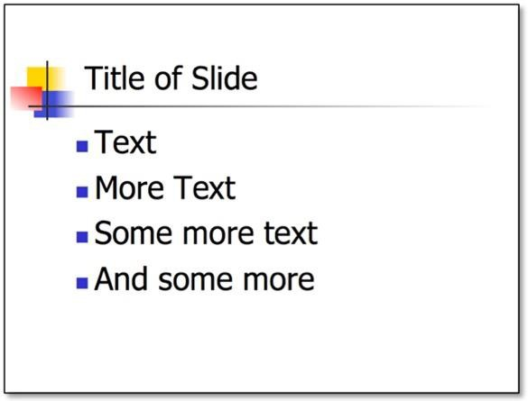
Fig. 1. Examples of style templates for slides. (a)

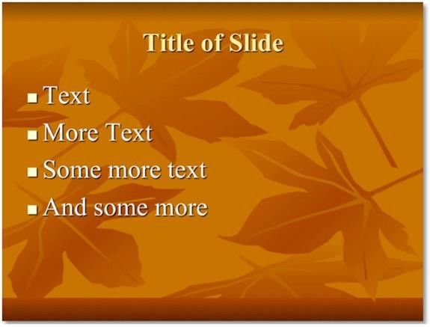
(b)

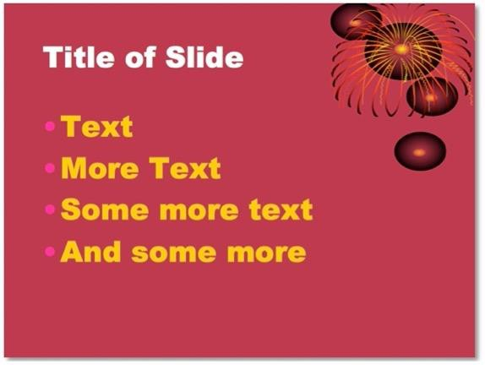
(c)

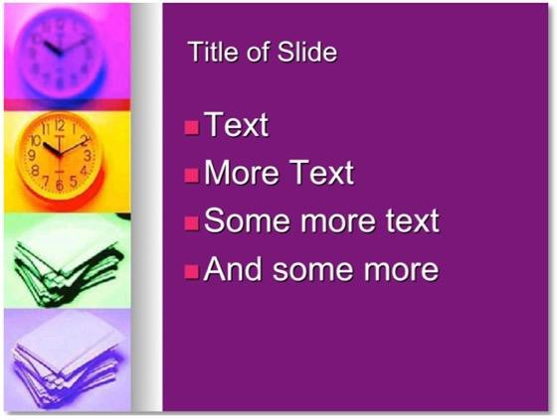
(d)

Example (a) has clear simple text, but on a white background. Many presenters, prefer light text on a dark background as they believe it is easier to read and creates an illusion of depth in the slide. Other presenters, myself included, prefer light backgrounds with darker text and images. One of my reasons for this preference is that the slides being generally lighter often add much needed illumination to a very dark lecture room. This template example also has a simple and colourful little logo that will be interesting for the first couple of slides, but by slide 37 may well have lost its appeal.

Example (b) has light text (white or yellow) on a darker pink background, but again this slide has a graphic element—in this case, what looks like a firework—in the top right quadrant. Even if it’s relevant to your talk, just like the little logo in example (a) it will become grating if it is present on every slide.

Example (c) has a background graphic of autumn leaves, which I feel adds unnecessary complexity to the slide and inevitably detracts from the texts and images. The font used is Times New Roman, which is often thought to be more difficult to read on screen compared to Arial for example, even though it is easier to read in printed text. Also, the colour scheme here is an odd brown and yellow combination, which to my eyes says “dull”.
Example (d) is one I have seen used more than once, but my main concern here is why would you allocate a quarter of your precious slide space to a meaningless graphic that is again going to become very boring after a few slides.
One concern with all these examples, and indeed with many pre-set templates, is the inclusion of fixed design elements that will appear on each and every slide. These are frequently gratuitous images or graphics that have no purpose other than to provide decoration. There really isn’t enough space on any slide to include anything that doesn’t need to be there. And with the 3MT® Competition you certainly cannot afford to squander the space on that single slide.
These are just four templates selected from hundreds. Of course, you can create and work to your own template, which can be anything you choose. Commonly this will be a plain simple monochromatic background with a simple header device and a simple uniform font. As noted above, I personally do not like meaningless graphics such as swirls or leaves or snippets of Mondrian’s Art in the corners as I feel it detracts from the content of the slides and very quickly becomes tedious.

The use of graduated backgrounds, where the colour is darkest at the top or bottom of the slide and gradually lightens as you move down or up the slide, can work well, but, again, it is a subtle complication that you don’t really need, so think carefully before you include it. Also, if the gradation is extreme—for example, going from black at the top of the slide through every shade of grey to white at the bottom—what colour should your contrasting text be? The same problem arises for those who opt for a rainbow effect of background colour, and this is a complexity that is best avoided.
Some presenters are fond of using background photographs, which may or may not have anything to do with the content of the slide. I have seen holiday photographs used depicting beautiful beaches, underwater coral reefs, or exotic temples; I have seen snapshots of the presenter’s children and even, on one memorable occasion, their pet. An example is shown in figure 2. In this, and all the other occasions I have mentioned, the use of a background photograph is usually very distracting and is best avoided.

Fig. 2. Using a background photograph can be distracting.
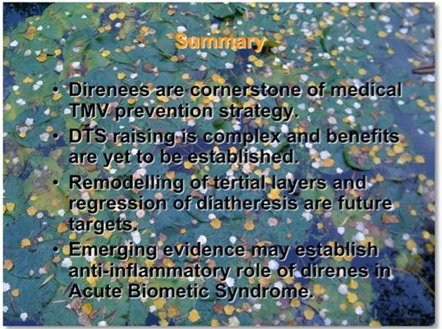

You may be obliged to have your institution’s logo on the slide and indeed may be tied in to a corporate style overall. In many instances, it seems that the people who prescribe these slide styles have no graphic design credentials and may never even have given a presentation. As such the corporate or institutional style may be very awkward. That said, you will often have to go along with it, but where possible keep these additional elements to a minimum especially when they include text. A University crest is one thing, but do you also need the full name of the college on every slide, along with its motto in Latin or even its mission statement? Also, while you may have to comply rigidly to your institution’s style guide for your title slide, might you use your own, simpler, less-cluttered approach for the content slides?

When it comes to choosing type face and fonts the criteria are simple: the text must be clearly visible and easy to read. Type faces roughly fall into two categories: so-called serif fonts and sans-serif fonts. Serif fonts have little twiddley bits on the letters and the most common example is Times Roman. Sans-serif fonts on the other hand are cleaner shapes without additional flicks and examples of these are Arial, Verdana and Gill Sans MT. So, which should you use on your slides? People tend to read serif fonts slightly faster and more efficiently when they are reading text on paper. That’s probably why most newspapers and magazines use serif fonts.
However, when you ask people to read text projected on a screen, they tend to favour sans-serif fonts. For that reason, I always use sans-serif fonts in my slides. Whether this distinction holds when the text is not projected but displayed, say on a plasma screen in a lecture room or on a computer screen over a zoom meeting, is debatable. Given that you often don’t know what media will be used until you show up to give your talk, its best to assume they will be projected and go for the simpler type faces.

Again, as with backgrounds, consistency is important and the same font should be used throughout, although the size and/or colour may vary for emphasis and effect. When it comes to size, a useful guide is never to use a font size smaller than about 24.

Overall, your aim should be to keep the style of the slide simple and allow its contents—the words and pictures you will add—to speak clearly for themselves, unmuffled by excessive design elements, muted colour schemes and difficult to read fonts.



‘W’ IS FOR WORDS
The most widely perpetrated slide crime is overuse of text. Virtually every guide written on the preparation of slides emphasizes that there should be a strict limit to the number of lines of text on a slide. Depending on the guide, this is usually between 5 and 7. In addition, a good rule of thumb is that each line should only have 5 to 7 words.
This is very constraining, especially if you are using your slides effectively as notes that you plan to read to your audience. Well, first of all, this should not be the purpose of your slides: they are there to help emphasise and illustrate the points that you are making, not as your script. Most of the words in a lecture should be spoken, Those that are on the slides are simply signposts or key words to underscore your arguments. Second, if your slides contain virtually all the text you plan to say, they will be impossibly dense and completely dysfunctional as visual aids, being neither visible nor helpful.
The text on your slides should be clear, simple and short. The use of full sentences is rarely required unless you are showing a quotation, and bulleted points are always preferable to prose. The use of bullet points rather than sentences or paragraphs of text forces you to be concise and to focus on only including the key words and phrases on your slide that you need to make your point. As you are designing and editing your slides, always ask yourself the question, “Can I say this in fewer words?’

When it comes to checking the number of lines on your slide, remember to include any header or title line you are using, as well as any footer or reference line—these lines are still on the slide and your audience has to look at them and read them.

Often speakers like to include slide numbers and possibly the date of preparation on their slides. I would strongly advise you to resist this. These figures will appear in the corner of the slide and are nothing but a distraction. Some slide making programs will automatically default to this format. If this is the case, you should take the two minutes needed to remove these features so that your slides are cleaner and less cluttered. Why would you want a date on your slides—on every slide? Vintage wines, yes: slides, no. It only means that if you ever want to use the slides again, they will immediately be out of date. Similarly, what is the purpose of a slide number? Perhaps if you have twenty slides and you are so nervous giving your presentation that you are unable to orientate yourself, it might be comforting to know you are half way through when slide number ten appears. But really, you should not have to rely on such an approach. All you have done is included extra, unnecessary information and text on a slide. Also, if you choose to use the same slides again, perhaps mixing them with others and slide numbers are fixed elements, your numbering strategy will be blown. As always, you should only include text and images on a slide that are absolutely necessary. There is no space for anything that is less than essential. And remember, slide numbers and dates will contribute to that precious line and word account.
In academic circles, many slides will carry some form of referencing. Unfortunately, more often than not these references are unreadable, even by the speaker, as the font size used is so small. It seems obvious to state that there should be no text on your slide that the audience cannot read, but every day I see slides being used that contain miniscule reference lines at the bottom. If you need references, make them readable and keep them as short and simple as possible. Occasionally several references are used—I have counted up to ten on one slide. Again, it may be stating the obvious, but don’t try to pack too much information into too small a space. If the content of your slide requires ten references to back it up, you are probably asking too much of that slide.

Lastly, some lecturers like to use upper rather than lower case lettering. This is presumably done for emphasis, as capitalized words appear to shout from the page or screen. What you need to be aware of, if you do this, is that people read capitalized text significantly more slowly than lower case text, and this is especially true if they are reading your text in a second or even a third language, which might well be the case if you are presenting to an international audience. If you want the text on your slides to be as easily read as possible, then I suggest you stick to lower case except for normally capitalized letters.



‘I’ IS FOR IMAGES
The use of images whether they are photographs, diagrams or graphs, is, in my opinion, the most important use of slides. Words you can say, but pictures you have to show.

Graphs
Many of us will use graphs such as histograms, line graphs and scatter plots to illustrate our talks. These images may be complex, and many presenters fail to give their audiences enough time to take them in. The presenter will of course be completely familiar with the graph they are showing—they may have even collected the data used to construct it and drawn it. But, of course, that means the presenter has perhaps had days, maybe even weeks to become familiar with the graph and its significance. Now, that same presenter expects you, a member of the audience, to assimilate that graph in just a few moments.
This is a problem peculiar to slides where a pre-drawn image is shown. In days gone by, when a presenter had to rely on a blackboard and chalk, if they wished to show a graph, they would have had to draw it. The advantage of this is that most presenters can only draw at the same speed as an audience can understand.

Put simply, graphs are hard to take in and the audience needs time to do so. Look at the example in figure 3. Here, for example, a speaker might say:

Cholesterol and heart disease are obviously related…
And move on.

Fig. 3. Slide showing the relationship between cholesterol and risk of coronary heart disease.


That approach took less than 5 seconds and no one in the audience could have looked at the slide and understood its contents, so why bother showing it? A simple rule to follow, when you are showing a graph on a slide, is to imagine that you are drawing it for the audience as you describe it. Tell them what the graph is about, define the axes and say what it shows.
So, now the speaker might show the slide in figure 3 and say the following:
This graph shows the relationship between serum cholesterol on the x-axis and death from coronary heart disease on the y-axis. As you can see, as the serum cholesterol increases in the population so does the risk of death – the relationship is not however a straight line but a curve which becomes steeper and steeper as we climb through the cholesterol range.

Slide flashing—showing complex images like graphs so fast that no one can assimilate them—is a particular crime of so-called experts. All it really says is: ‘I’ve got all these slides and I couldn’t be bothered sorting through them and preparing an appropriate talk for this specialist audience because you’re not really worth the
effort.’ This also happens a lot with undergraduate teaching where senior academics do not feel the need to adjust their styles to accommodate the needs of their students, preferring to re-use their latest conference presentation on the first-year students. Needless to say, this is not lecturing, it is simply indolence.

Graphs should, as always, be uncluttered and not contain unnecessary information. It is tempting to scan graphs into your presentations from journal articles or other sources, but inevitably these sources were not designed for projection. As such, they will contain additional text, or their colour schemes will be difficult to project. It is cumbersome, but very worthwhile, to redraw the graph so that it suits your presentation and conforms to your style. Occasionally the graph may be so complex that it is impossible to redraw without access to the original data—if this is the case you might ask yourself if you should be showing such a complex image in the first place.

Diagrams
The use of diagrams or figures can greatly enhance a presentation. Often abstract concepts can be represented and made clear by a good diagram. As noted in the case of graphs, the temptation to re-use scanned images without altering them to fit your style should be resisted. If you do have to use a copied image, at least take the time to delete or cover up any unnecessary details or associated text. This will make the image much more useful and will allow your audience to concentrate on the relevant part of the image.

An example of a slide with complex scanned elements from two papers is shown in figure 4. In this case, the speaker might spend time with their laser pointer directing the audience to the parts they wish them to focus on. But why show material that is irrelevant and that you want the audience to ignore? Slides simply aren’t big enough for that kind of indulgence, and all it does is force you to keep the relevant material smaller and more difficult to see.

Fig. 4. A complex slide using a scanned table and composite graph from two academic papers.


Very easily this slide can be converted into alternative better versions by simple cutting and pasting of the relevant portions as shown in figure 5.

Fig. 5. Two simpler versions of the slide shown in fig. 4. Here the table and the composite graph have been cropped and enlarged to show the relevant portions.




Photographs
Photographs are essential elements of many presentations. If you are speaking about the History of Art, how could you do so without showing slides with photographs of paintings or sculpture? If you are describing the marketing plan for a new brand of cereal, how could you avoid showing photos of the packaging and advertising? Other topics such as financial advice or English literature may not be obvious contenders for the use of photos, but I would strongly urge their use where possible.

Slides that only contain text very quickly become tedious—at least they do to me because I am one of your audience members who learn from a combination of words and pictures. Why not illustrate your talk on Romantic Poetry with a portrait of Shelley, or your lecture on Individual Savings Accounts with a stock photo of a typical family or elderly couple who may be the investors in your case study. Think about how newspapers and magazines do it. Even articles about abstract concepts are wrapped around images that somehow evoke the themes therein. The editors do this to draw your eye to the article. Although your slides should not merely be used for attention grabbing, a carefully selected image may compliment the words you are saying, or the text you are showing, and may make the point more memorable.

Where to find pictures

People who compliment you on your slides will often ask where you got the pictures you use. Words, for most, are the easy part of slide design, but they stumble when it comes to combining those words with appropriate images.
Images are usually obtained from four sources: clip art, the Internet, stock image libraries or your own collection.
Most people have access to clip art in their slide making software, e.g. Microsoft PowerPoint. The problem with clip art is that everybody else has access to the same pictures too. How often have you seen slides with those little stick men, or those immediately recognisable cartoon birthday cakes or balloons? If you do decide to use clip art, there is one very simple rule to follow: don't mix styles. Often a slide that is relying on available clip art will have several pictures all drawn in a very different
style. This adds to the audience’s confusion in trying to assimilate the information on the slide and altogether makes it look rather messy. Two examples of the same slide are shown in figure 6, one with a mixture of styles and an alternative, still using clip art, that uses a more uniform approach. Which do you think looks better?

Rather than confining your selection to a clip art library, why not make use of the countless images available on the Internet? Websites abound with useful images that might be used to enhance your slides, but can you use them? Well, of course you can – nothing is simpler than right clicking over a website photo and saving the picture and then inserting it into your slide, a task that takes literally seconds – but the question is: should you?

Fig. 6. Alternative versions of the same slide, one using a mixture of image styles and one using a consistent approach.




Copyright issues on the web are complex and, as far as I can see, still being defined. However, there are some sites such as Wikimedia Commons that are very useful resources.

Wikimedia Commons is a media file repository making available public domain and freely-licensed educational media content (images, sound and video clips) to everyone. The files are uploaded by individuals from across the globe and the Wikimedia Foundation owns almost none of the content on Wikimedia sites—it is owned by the individual creators. However, almost all may be freely reused, but the Wikimedia Commons site does counsel that if you decide to reuse any of the material, “you should make your own determination of the copyright status of each image just as you would when obtaining images from other sources.”

When searching for appropriate images on the internet to include in your slides, do make use of the advanced features of search engines such as Google. Using these, you will be able to specify some of the attributes of the image you are looking for by applying filters (such as content—do you want a photo or a line drawing or even a piece of clip art?; orientation—landscape or portrait; colour—do you want a black and white or a colour image?; and image size).
Many people who capture images from websites to use in their slides make the mistake of picking very small, low-resolution images. When applied to your slide, and perhaps enlarged to the size of a small tennis court on the screen, they appear blurry and pixilated. I usually specify medium, but you can also get good resolution images with other size settings depending on the type of image you are looking for. Importantly, you can also limit your search to only those images that have been labelled for reuse or non-commercial reuse.

Using this advance searching strategy will save you a lot of time and will only bring up for review those kinds if images that you are interested in and not the thousands of others that don’t fit the bill.
On the Internet you will also find sites that are essentially image shops, where useful and often very beautiful images can be purchased for a variety of uses, including slides. One of the largest of these is iStockphoto. There you will find literally millions of photos, drawings and video clips for purchase. Their site is also worth visiting as they regularly offer free photos and videos for download. The cost of the various pictures or videos is variable and depends on the size. These images are always very high quality and can significantly enhance your slides. However, they will rarely be personally relevant, and you do have to pay for them.

The best source of images is, however, your own camera or smart phone. These images have the huge advantage of originality and of course there are no copyright issues. The same clip art images and even photos are seen in many presentations, but your own photography is unique to you and adds a highly personal touch to your slides.

Other kinds of image Screen shots
In your presentation, you may wish to make reference to the use of computers. Often, when this is the case, speakers may choose to show images of the screen from particular programs—or screenshots. For example, if you were giving a presentation about how to complete an online form, you might capture a series of screen shots to illustrate the procedure.

The problem with this is that the information on a computer screen, which may be only 30-50cm from your nose, is much more visible than the same information projected on a lecture room screen. Thus, screen shots contain text that that is often too small to read, as well as a lot of extraneous detail, such as screen headers and navigation bars.
This does not mean you cannot use screenshots, but it does mean you have to think about it. Often, you are showing a screenshot because you wish to highlight a particular function, e.g. where the help button is, or how you use the navigation bar on a website. If this is the case, rather than simply showing the whole screen, why not select a small section of the screen, blow it up and show that instead. It will only take a few moments to do this, but it will mean that your audience will actually be able to follow what you are saying without requiring a new prescription for their glasses.

ACTIVITY 1
A common use of slides is to summarise and display data. These may be quantitative data such as sales figures, lab results or performance indicators, or qualitative data such as customer comments and opinions.
Below you will find three slides, all showing the same numerical data that relate to applications for a specific study grant awarding body in the UK from 2013-18, but in each slide the information is presented in different ways.
Compare each of the formats and assign a score to each of the slides according to their quality of design and presentation. Which do you think gets the gold medal, which the silver and which the bronze?


Option 1

Option 2


Option 3


ANSWER
People respond in different ways to different forms of presentation. That said, there is a general principle that I think is particularly appropriate to slide design, and that is if you are showing data the best way is in a picture, the second-best way is in a table and the least effective way is to present the data simply as text.

In this example, we have a simple set of quantitative or numerical data presented in each of these formats—words, table and picture.
The first option is effectively a script of what the presenter might be saying to describe the data, but importantly it doesn’t actually show the data. In the second option, we have the table of raw data, and in the third option we have this data represented graphically. In the latter two options, we have shown the audience all the data and it will inevitably require some explanation and interpretation, perhaps akin to some of the bullet point text in option 1.
Overall, if we have to show just one slide, I think option 3 is the best and most readily allows the presenter to describe and talk through the data. I think option 2 is a poorer version than the graphical option, while option 1 is providing a partial interpretation of the data, but without presenting the complete picture.



‘P’ IS FOR PALETTE
As with background designs and text fonts, when it comes to colour schemes, you literally have the full spectrum to choose from. But some colours and colour combinations work much better than others.

In choosing your palette, you should pick not only the colours that you like but that work well together. You are especially looking for colour contrasts. Light green text on a pale-yellow background, or a purple line drawing on a blue background do not work well because there is not enough contrast between the colour pairs for the audience to see the content clearly. Instead, look for more extreme contrasts: black and yellow, blue and orange, white and dark green.
As before, I would counsel simplicity. Just because you can use hundreds of colours, doesn’t mean you should. Interestingly, when professional graphic designers embark on a new project, they often define a simple and limited palette of
colours that they then use repeatedly throughout. This is a good practice to emulate. You may, for example, choose a single background colour for all your slides, one or more text colours and perhaps, if you are showing a series of graphs, re-use a few simple colours there too. Slides that use lots of different coloured backgrounds, fonts and other design elements can become confusing and distracting, as well as looking unprofessional.

Fig. 7. Examples of slide colour schemes.
- Although red on black looks fine when printed or displayed on a computer screen, it does not project well and should be avoided.
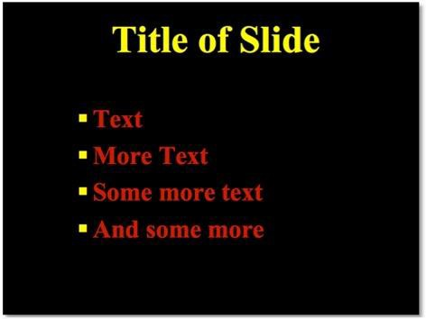

- Red on green or vice versa should always be avoided.
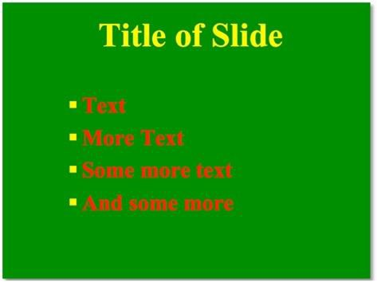

- White or yellow on a dark background always works well.
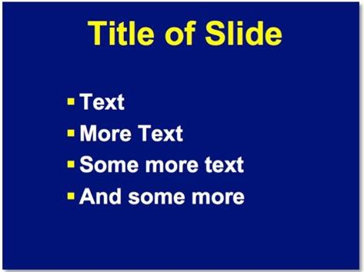

- Dark text on a contrasting light background can also work well.
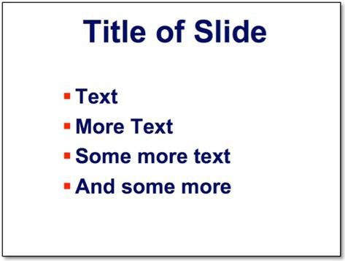

When choosing your colour palette do bear the following important points in mind.

Take care when using red
First, remember that the colour red—red texts, red lines, red figures—does not project well and is often completely invisible especially if the contrasting background chosen is black or dark blue. Perhaps the reason why this colour choice is used so often and causes so many speakers problems is that most people design their slides on a laptop where the LCD screen makes the red, even against a dark background, stand out brightly. The first time the presenter sees the slide projected is when they stand up to deliver their talk. Suddenly in a room where the lighting controls make it difficult to fully darken the space and perhaps with a poor projector or screen, they realise that their red text is unreadable and their red diagrams incomprehensible.
This is not such a problem if your slides are being displayed on a plasma screen rather than being projected. However, as you may be unaware of the exact media in use at the venue where you are to speak, it is always safer to assume the worst and proof your slides against this possibility by avoiding the combination of red and dark backgrounds.

Using simple contrasting colours
Tried and tested colour schemes are white and/or yellow on dark blue or black backgrounds. Such colour combinations are seen nowadays as dated, even clichéd. However, to become a cliché you have to be used a lot and the reason these colours schemes are used is because they work. You may, however, be particularly prone to purple or green or burnt sienna and of course there is no problem in using alternative background colour schemes, but you should consider very carefully the corresponding contrasting text and graphic colours.

Considering the colour blind

Another consideration when choosing your colour palette is to remember that around one in twelve of the males sitting in your audience are colour blind and may have trouble distinguishing your colour schemes, especially if they are based on reds and greens. Although there are other forms of colour blindness, red-green is the commonest. Despite this, I cannot count how many times I have seen slides used with red text on a green background, bar graphs with adjacent red and green columns and scatter plots composed of red and green dots. Clearly such a combination should be avoided.

Citing websites in slides

One final consideration is the citing of websites in slides. If you wish to include the URL of a website on your slide, perhaps to tell your audience where they might find further information, pay attention to colour schemes. When you type a website address in, for example, Microsoft PowerPoint, it will default to being a hyperlink and will acquire the font colour set for hyperlinks in your program. This colour may be very unsuitable. For example, the default colour may be blue, and your slide background may also be blue. Obviously for the URL to be visible you will need to change the colour, but this cannot be done in the usual way. Because the program thinks it’s a hyperlink you will have to change the default colour of all hyperlinks.

Conclusion
Whatever you choose—a colour scheme that is tried and tested and acceptable to most audiences or something a little more quirky, individual and therefore risky—keep it consistent. Use the same background format and colour scheme throughout your lecture. This will make your presentation more coherent and will allow your audience to relax a little and concentrate on the slide content rather than trying to work out why one slide is blue, the next is yellow with flowers down the side and the third black and white.



‘E’ IS FOR EXTRAS

By extras, I mean those embellishments that any slide presentation software allows you to add to your slides to make them even more interesting visual aids. Usually this is in the form of some visual effect, such as a simple transition effect, build or animation, but it may also be the use of a sound effect, or it may be the embedding of a short audio or video file that can be played from within the slide set.

While many academic presenters will rely heavily on such extras, the rules of the 3MT® competition are clear when they state that none of these is allowed. You will be required to show only a fixed, static slide from the beginning of your talk. There are no reveals, no animations, no embedded video clips, so at least that’s one thing you don’t have to think about.

ACTIVITY 2
Although judging whether a slide is good or not may seem highly subjective, there are, I believe, a number of objective tests of slide quality. In order to tease these out, we need to study slides in detail.

Look at the slide below and consider not its contents but its design. I think there are several major problems with the design, and a number of simple things we could do to make it a more effective slide—do you agree, and if so, what do you think they are? Think about your own answers before seeing what I have to say.

Slide for analysis


ANSWER
The easiest way to deconstruct and critique this slide is to use our acronym SWIPE and look at each of the components in turn.

Style
The presenter who used this slide employed a template that dictated the colour scheme, background graphic and fixed-element imagery. Background graphics are often distracting, and in this slide, I think they are especially confusing. I remember looking at this slide when it was being presented at a talk I was attending and my
first thought was, “What is that in the background?” Needless to say, as a member of the audience that should not have been my initial concern. What the graphic represents is a map of the UK overlaid with what look like tyre tracks. Neither of these were particularly relevant to the topic of the talk. In addition, we have a fixed element in the top left-hand corner which depicts five faces. Again, these were irrelevant to the presentation and were merely included to add some graphical interest to the slide template. In other words, they were meaningless, gratuitous and taking up valuable space on an already crowded slide.

Words
One of the major problems with this slide, as with many slides, is that it contains too much text. There are 17 lines of text not counting the virtually unreadable footer and reference. One plus point is that the text has been written as a series of bullet points, but the overall impression is still of a very busy slide. Such an amount of text ideally should be spread over two or more slides, but it is always worth asking yourself if you really need to show it all. The font used is a sans-serif one which is good for projection, but because there is so much text the font size is smaller than ideal. This is especially true of the footer and reference. Some would argue, “it’s only a reference, no one needs to read it.” However, I firmly believe that if there is text on a slide, it must be readable from the back of the room. The reference is also given in a very full format, such as would be used in an academic paper, and for the purposes of this slide it could be significantly abbreviated, and the font size increased accordingly.

Images
Apart from the image components of the slide template, which we have already critiqued above (the background map and the faces in the top left-hand corner), the slide contains no other images or graphics. As it stands, there would no space to include any further images. If, however, the text was reduced and the slide simplified, it may be possible to present some of the text, such as the numerical data, in graphical form.

Palette
The only right colour scheme is the one that works. To work effectively, we need as big a contrast as possible between the background colour and anything you place on top of it. In this slide, the purple/yellow combination is less than ideal. This is

especially so because the yellow used is quite a dull one and the background purple is varied from pale lilac to darker purple because of the background
graphic. Overall, this would be a better slide if the background was made darker and a constant shade of purple, while the text was lightened to improve the contrast.

Extras
Because we are reviewing a static image, we cannot really comment on any transition effects or builds that might have been used when it was delivered. This slide would probably be more effective if the different items of the bulletted list were built one by one rather than simply shown in their entirety, but of course, such a strategy would disqualify you in the 3MT® competition.



EXAMPLES OF WINNING SLIDES

Building on everything I have said about effective slide design, it is useful to look at slides that have been used in recent winning presentations in the UK 3MT® Competition. It should be remembered, however, that looking at the slide in isolation is not how the judges saw it. They were presented with the package of a single visual and either a live presentation by the student on the stage in front of them or in the last couple of years an accompanying video of the talking head of the presenter. Their words, intonation and gestures were all part of the presentation and to look at the slide separate from everything else is a little unfair. That said, we can draw some useful conclusions from their study, so let’s take a look at some examples from the last four years.

In 2021, the Judge’s choice prize went to Ana Pavlović from Kingston
University, with her presentation entitled, ‘Prestress losses of pretensioned BFRP reinforced concrete beams’.
Interestingly, her single slide shown below had no words and a single image of a child’s toy that she referred to in her presentation, using it as a simple, familiar analogy for a complex concept in material science.

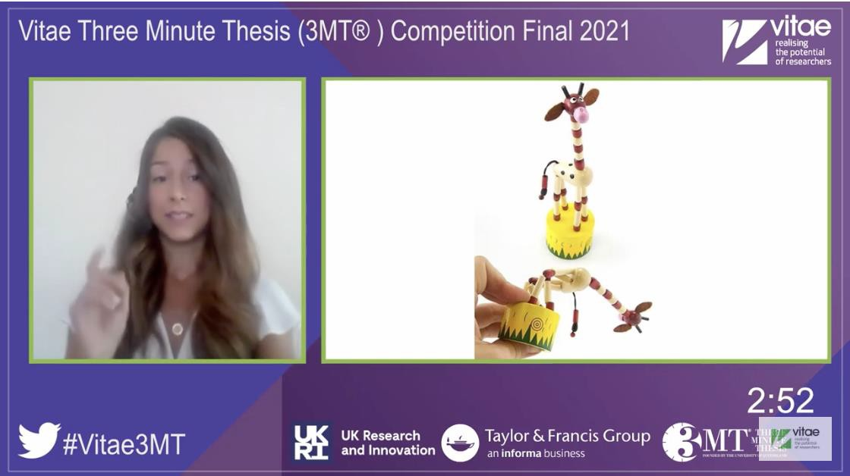

The same year the People’s Choice Prize was awarded to Manuela Carnaghi from the University of Greenwich, entitled, ‘Houston—the mosquito has landed’.
Her single slide shown below was a mock-up of a news flash on the BBC website announcing the demise of mosquitos featuring a large photograph of the blood-sucking insect. She alluded to this at the end of her presentation with the words, “One day we will see news like this.”

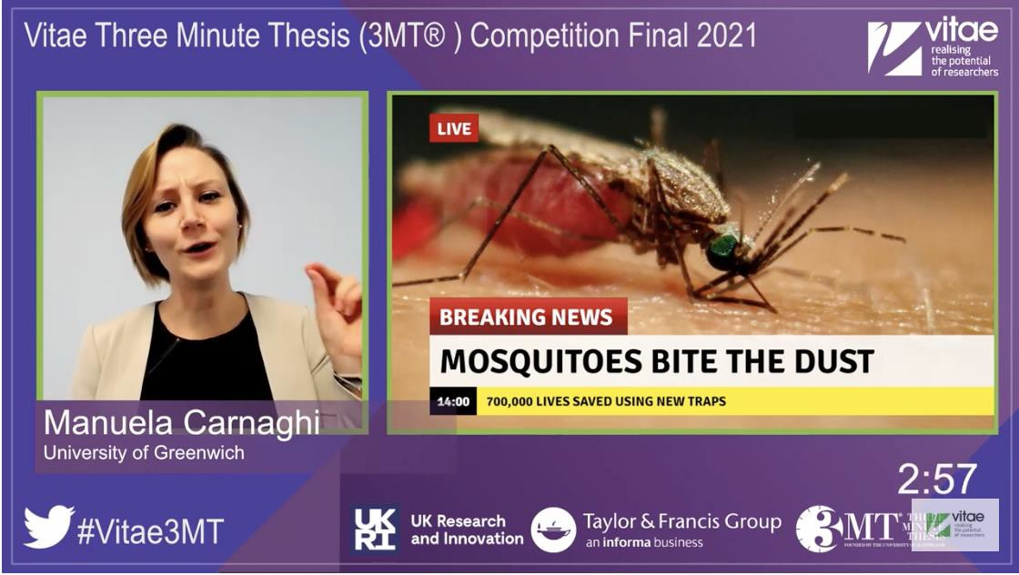

In 2020, Lucy Thomas from the University of Birmingham took the Judge’s Prize with her presentation entitled, ‘Gravity is Pathetic! Shedding Light on Gravity with Models of Spinning Black Hole Mergers’. Again, interestingly, her slide had no words.


The People’s Choice Award that year went to Vinaya Srirangam Nadhamuni from Queen Mary, University of London with her presentation entitled, ‘The war on cancer: understanding the immune system’s strategies for fighting bowel cancer’.


In 2019, the Judge’s Prize went to Shruti Mandhani, from Sheffield Hallam University with her presentation, ‘High performance polymers: towards intrinsically-auxetic polymers’ and the People’s Choice to Oluwashina Akinsanmi from Ulster University with his presentation entitled, ‘Antibiotic Resistance Crisis: The Sawdust Redemption’.


This slide consists of a series of images and only a few words.



This slide is essentially a flow diagram of the process being describe, mixing photographs and simple images.

Lastly, in 2018 the winner of the UK 3MT® Competition was Owen James from the University of Edinburgh with his presentation entitled, ‘Human myelin in a dish’.


This slide has the title of the presentation in the centre and around it a series of images connected with arrows mirroring the flow of the argument presented in the talk.

One of the first general observations that might be made is how few words are used compared to pictures in these slides from winning presentations. Most early drafts of 3MT® Competition slides, in my experience, are text heavy because the presenter is trying to condense a lot of information, perhaps from multiple slides they have already created, into a single image. Either no or very little text does make the slide much easier to engage with and overall makes the slide simpler and more effective.
At least three of the examples from the last few years’ winners are what might be called ‘backdrop slides’. They are composed of single images that are trying to evoke the overall thrust of the presentation without trying to repeat the same kind of detail the presenter will give in their talk. These can be very effective given the time constraints faced by contestants. In contrast with a more conventional research presentation where the speaker may be using slides to help develop the argument, present key findings and come to conclusions, the 3MT® Competition is about quickly engaging with the audience, convincing them in almost one sentence that what you are talking about matters and then bringing them into your world.

One final observation—all the recent winners used a slide. There are finalists who have chosen not to use any visuals, but interestingly none of them have won. In the academic setting in which this competition is being run, it might be regarded as a

missed opportunity not to supplement your voice and your presence with an interesting engaging and potentially informative visual.

If you want to see how these slides were used in the presentations, you can watch videos of all the finalists and the winners at the 3MT® Competition website which is listed in the resources section.



CONCLUSIONS
Let’s tie things up. Participation in the 3MT® Competition can be a be very valuable professional experience. It will allow you to work on your oral presentation skills, to think about how you can communicate effectively with non-specialists, and it will allow you to enjoy contact with other academics across different fields. And of course, if you are successful, it’s not going to look too shabby on your academic CV.
Part of being successful will be designing and choosing the right slide to accompany your talk. This needs to be an effective single slide that serves as a good visual aid to support and enhance your presentation rather than overwhelm or distract your audience, including the judges.
With that in mind, this Study Guide is designed to help address what I and many others see as a real problem. Put simply, many speakers use slides that are quite simply terrible. They may be terrible for several reasons. They may be overcrowded with text, they may be overloaded with images, they may use fonts that are too small or too frilly, they may be dressed up in colour schemes that hurt the eyes or make it impossible to make out what is what. Or they may even be all of these things at the same time. What these slides are not are clear, uncluttered and thoughtfully designed. The principles of good slide design are, however, not complicated, with simplicity as the overriding consideration. If you apply these principles, they will guarantee the production of good slides every time.
I hope this Study Guide has given you some thoughts on how best to design that all-important single slide for the 3MT® Competition.



FURTHER READING & RESOURCES

As always there are more books written on slide design than you could ever hope to read, so I have listed just three below that you may find useful.

slide:ology: The Art and Science of Creating Great Presentations. Nancy Duarte. O'Reilly Media, Inc, 2008.
Nancy Duarte, the author of this book, runs the company that created the presentation for Al Gore’s film An Inconvenient Truth, proving that you can win not only an Oscar, but also a Nobel Peace Prize, with a great slide show. Her book, therefore, needs little more recommendation, but you will find that it is packed with great ideas and sound advice about slide design and is written on the premise that you should “never deliver a presentation you wouldn’t want to sit through.”

Presentation Zen: Simple Ideas on Presentation Design and Delivery. Garr Reynolds. 3rd Edition New Riders, 2020.
This book is a simply beautiful object and is full of new (at least new to me) ways of designing slides for more effective presentations. The emphasis is on business presentations, but most of what is included could be easily adapted

for other settings including the 3MT® Competition. Hundreds of examples are shown in full colour, and even the foreword is presented as a PowerPoint slide show.

A Handbook for Teachers in Universities and Colleges: A Guide to Improving Teaching Methods 4th edition. David Newble and Robert Cannon Routledge, 2000.

This is one of the first books I read about lecturing and teaching and remains one of the best. It has been updated and revised several times over the years and it is the one book I always recommend to new university lecturers, no matter what their discipline. It contains useful information not just on how to make effective slides but how to use them and other visual aids in your presentations.
If you want to watch some 3MT® contestants in action and watch how they used their single slide, you can watch videos of all the finalists and the winners from the last few years at the 3MT® Competition website.
https://www.vitae.ac.uk/events/three-minute-thesis-competition

ABOUT THE AUTHOR

Allan Gaw, MD, PhD, FRCPath, FFPM
I have worked in academia for over 30 years and for the last ten I have been running courses teaching under graduates, post graduates and academic staff a range of essential academic skills. Amongst these have been presentation skills and effective slide design including working with contestants for the 3MT® Competition I have also authored or edited more than 25 books and I write a regular blog entitled: The Business of Discovery which you can access here: www.researchet.wordpress.com You can also follow me on twitter: @ResearchET or visit my webpage: www.allangaw.com

ACKNOWLEDGEMENTS

The contents of this Study Guide are based on face-to-face slide design workshops and 3MT® coaching workshops and online sessions run by the author over the last ten years.
All photographs are used under the CC-BY Creative Commons licence.
All images of the winners’ slides are taken from the vitae 3MT® Competition website.



