Time Management
Online Resource





Five steps to better time management

- Where does your time go?
- What should you be doing?
- What stops you doing the right things?
- What is the right time management strategy for you?
- Making the change

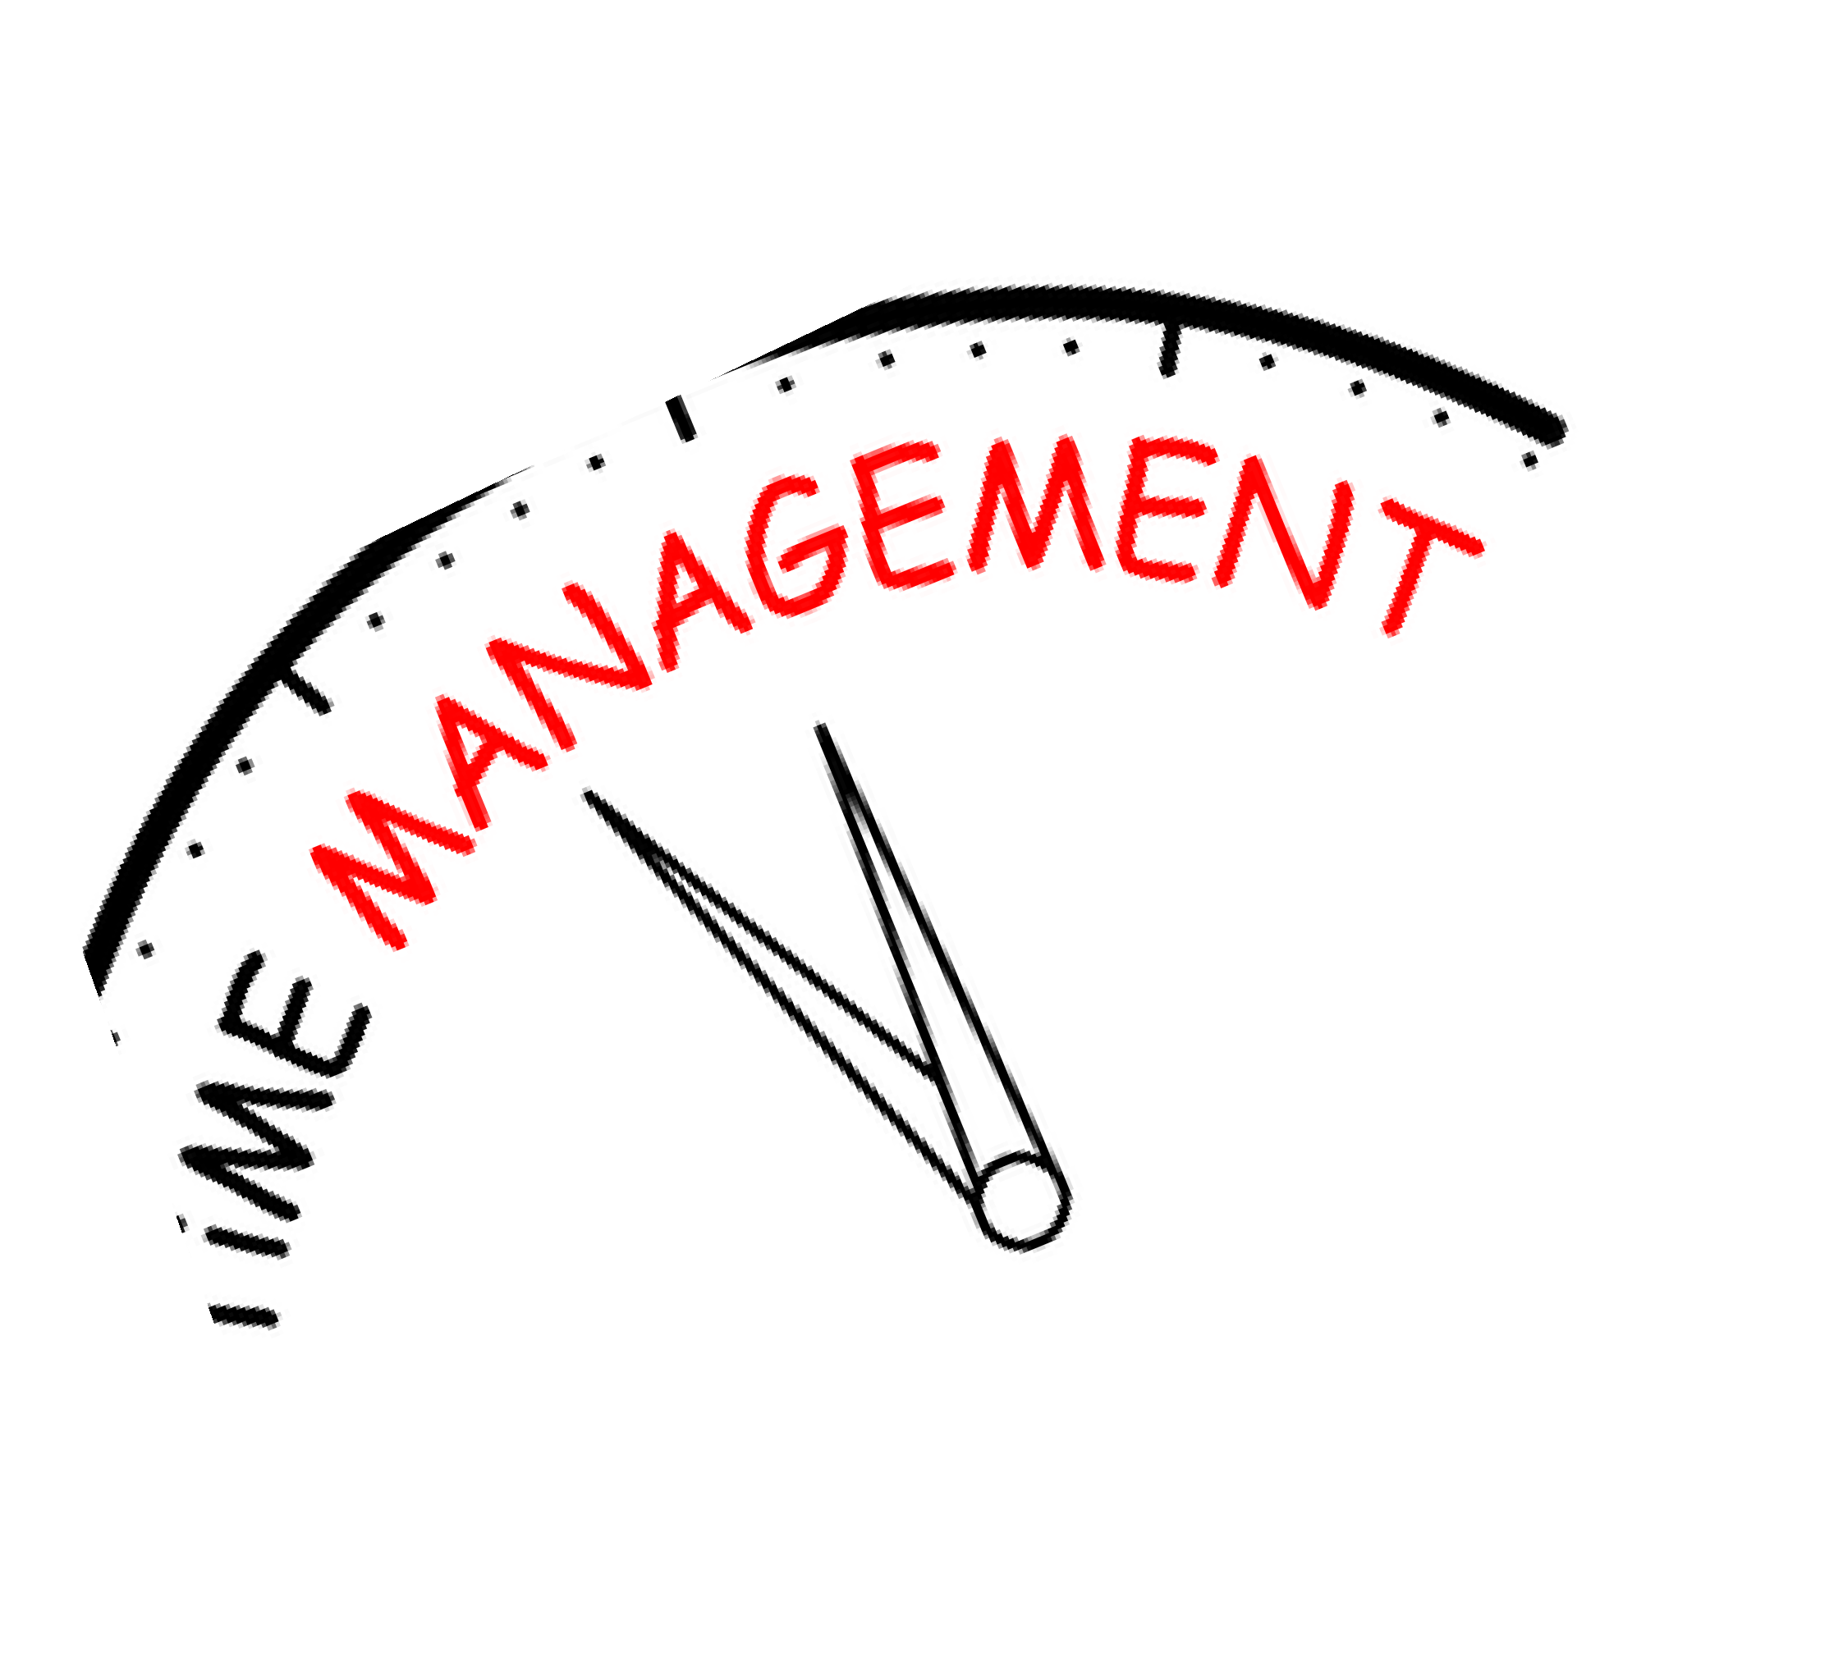


Where does your time go?

Before we can start to change our time management habits we need to understand the context in which things are going wrong. We need to have an accurate insight into the choices we make on a daily basis which are sabotaging our good intentions. We need to look for patterns of ineffective behaviour and opportunities to change.

This starts with a diagnostic. It’s a simple tool but will require a little discipline. For a week you need to map out the tasks you undertake to build a better picture of the context in which your time management is failing.

There are levels of sophistication to this diagnostic. At a basic level, you simply track what you are doing at a given time. You can decide how detailed to make your time map – it might be in chunks of 10 minutes, 30 minutes, hourly or daily.

You can add to the diagnostic with additional reflection points:
  - What did I want to be doing at this point?
  - Who or what has prevented me from doing more important things at this time?
  - Is this a time of the day at which I perform well or do have difficulty motivating myself?
  - What would help me to be more productive or prioritise better at this point of the day?

A sample time monitoring grid, shown on the next page, is a good tool to use.
You can map out your tasks, adapting it to cover the routine of your working week and the level of detail you want to analyse.

Where does your time go?

TIME LOG Date:
What do you want to achieve today?

Time | What did you do? | Importance Rating*
09:00
10:00
11:00
12:00
13:00
14:00
15:00
16:00
17:00
How much time did you spend on high importance tasks? Are you happy with how you spent your time today?
What would have saved/created time?
What do you want to do differently tomorrow?
*Importance rating is optional, but allows you to rate the tasks you have undertaken

What should you be doing?

A 2x2 grid:
Urgent and Important

You need to do this first…
Not Urgent but Important

This is the stuff that should be second in your priorities. Time should be scheduled and set aside for these tasks
Urgent but not Important

Most of us respond to time pressure rather than value. This often comes second, pushing out the “not urgent, but important” stuff
Not Urgent, not Important

But often fun… Or displacement activity Or SEPs*
*Somebody Else’s Problem

With a 2x2 grid, the key is to working out what is important, to understand what your role is and on what terms you will be judged.
If you aren’t focussing on your career progression and ensuring that everything you do is what you should be doing, what is expected of you and what you will be rewarded for, there is a danger that your efforts are benefitting others. This isn’t about being selfish, as collegiate behaviour and supporting your colleagues is important, as long as it isn’t to the detriment of your progression.
So, the next stage is to work out what your priorities should be.
  - What are the things that you need to achieve over the next year to benefit your career?
  - What are the key elements of your role?
  - What do you need to start doing, or do more of, to progress? (This might also be a good time to review what you need to stop doing.)

These tasks are the important ones and you will hopefully find it straightforward to work out which are urgent and which need to be scheduled.

What should you be doing?

Your key responsibilities:
(suggest no more than 4-5)

Immediate objectives for these responsibilities:

Theme | Next Objective

Long term goals:

Theme | Needs to be achieved in the next 6 months

You then need to look at what you spend your time doing and if you feel there is a disproportionate
amount of time spent doing things that aren’t important, you need to work out why. Does your role need to be reconsidered so you are rewarded for the things you spend all your time on? Are you taking on responsibilities which should be done by others? Or are you lacking motivation to do the things you should and therefore distract yourself with things that you enjoy even though they aren’t your responsibility?
Finally, if you look back at the 2x2 grid you’ll note that the final box isn’t labelled in the usual time management way with “drop this” because it’s sometimes important to spent a bit of time doing stuff that isn’t urgent or important. These tasks are often fun and allow a bit of breathing space. Some are not fun and do you no benefit. This is why you also need to understand WHY you spend time in, or not in, the boxes if you are going to change your time management habits.

What is stopping you doing the right things?

Never underestimate the tenacity of your bad habits. Don’t think that by attending a time management session you are going to walk out with a new approach that will instantly transform your life.
Instead hope that you’ll walk out with a bit of understanding about WHY your time management isn’t a strong as it could be.
Most people can complete the traditional 2x2 grid. With a bit of coaxing they can rank the demands on their time and energy in terms of importance and urgency. The key though, is to understanding why they don’t do the important stuff first, and that can be a lot messier to sort out.
So the time management grid can take on two different dimensions –
  - Is this problem about me and my behaviours? Or the way others behave?
  - Can I change this?
Traditional time management techniques work if you are the problem and you can change. That is usually only partly the case in academia. Other people and academic systems are often major factors in time management problems – and they need different approaches.
On the next page the grid gives suggestions on steps you could take to address any issues. There is then a blank grid on the next page you to complete.


“I love deadlines. I love the whooshing noise
they make as they go by” ― Douglas Adams, The Salmon of Doubt

What is the right time management strategy for you?

ABOUT ME ABOUT OTHERS
can adapt . . .
Traditional time management strategies
Self awareness - when do you do best work, analysis leads to understanding of how time spent
Ask yourself if you have created the problems with your behaviour
Schedule your own work as rigorously as you schedule "fixed" activities
Introduce thinking time to decision making Manage interruptions
Balance variety or focus to suit your preferences
can adapt . . .
Not simply time management - its about negotiation and communication

People understand - your role, your responsibilities

People are aware of and respect your career development

Don't sabotage your own diary - communicate existing commitments and negotiate deadlines in this context

Stop "sucking it up"

Wean people off instant gratification
Have positive alternatives to suggest if it's difficult to say "no"

Would a collective voice be more effective?

fixed/unchanging
Manage yourself - know your weaknesses Be realistic about level of commitment
Choose the things that fit your life, could mentoring help?

How do others like you manage?
fixed/unchanging
Are you alone?

What are the coping strategies that work for others?

Are there alternative paths you could take?

How do you schedule and control these things?

What is the right time management strategy for you?

ABOUT ME ABOUT OTHERS
can adapt . . .
can adapt . . .

Would a collective voice be more effective?

fixed/unchanging
fixed/unchanging

Making the Change

The final stage is the most challenging, it’s designed to help you unpick the problems with changing your behaviour and to identify what you really need to do to adapt to better habits.
The first step is to identify what you want to change - ideally something that will make a big difference to your time management.
Next think about what is stopping you from making this change – it might be other people, your own habits, the environment you work in or external deadlines. These are the resisting forces.
Now think about what the benefits will be of the change – this might be increased progress on important tasks, improved creativity or reduced stress. If the drivers which are stopping you make the change are largely external or other people, you need to think about the positive drivers that will convince them to accept the change.
Finally you need to address the resisting forces and make a plan. This might involve changing your availability (reducing open office hours for seeing students) or having a conversation with a colleague who consistently asks for things at short notice.
The final pages include a schematic to help you to map out your thinking, and an example of a completed schematic with extra notes.

http://www.ed.ac.uk/iad


5. Making the Change
Driving Forces
Resisting Forces

Be strategic – what is your role here?
Where should your talents be applied?
Are you the only person who could do this?
Who can support you to make the change?
Schedule a meeting to discuss this or time to plan changes

Work out which of these forces are key and who needs to be involved in the change
Accept that you’ll need to invest time now with a view to a longer term change for the better
What are your tools?


5. Making the Change

Hand over a committee responsibility to my RA
Time to delegate
Colleagues like status quo
Difficulty trusting people to
do things to my standards
More Time
Develop Others
Look more senior
Driving Forces
Resisting Forces

This might be the key element – if you can identify other things to do with your time that benefit your school and fit with other agendas, you might get senior staff to support the change
If time and trust are two of your resisting forces, you need to invest time in properly delegating. Schedule an afternoon to prepare and write a comprehensive brief. Then train your successor, agreeing how they will ask for additional help and give them responsibility for training THEIR successor

Be strategic – what is your role here?
Where should your talents be applied?
Are you the only person who could do this?
Who can support you to make the change?
Schedule a meeting to discuss this or time to plan changes

Work out which of these forces are key and who needs to be involved in the change
Accept that you’ll need to invest time now with a view to a longer term change for the better
Some useful tools:
PDR Delegation
Scheduling (blocking times in your diary for writing or planning)
Adequacy (learning what you can do that is just good enough rather than perfect)



This resource was created by Dr Sara Shinton
Sara was Head of Researcher Development at the Institute for Academic Development, University of Edinburgh, where her role was to provide strategic leadership for the IAD’s Researcher Development
provision, delivering excellence for all research staff and students in line with the University Strategic Plan and national policy and funding frameworks. This includes oversight of support and enhancement
activities for doctoral students, early career research staff, doctoral supervisors and Principal Investigators. Prior to working at the IAD Sara ran Shinton Consulting.

This work is licensed under a CC BY-NC-ND licence
To view a copy of this license, visit: https://creativecommons.org/licenses/by-nc-nd/4.0/

http://www.ed.ac.uk/iad

